**Date:** February 2014

Financial Industry Business Ontology – Indices and Indicators

*Request for Comments*

*____________________________________________________*

**OMG Document Number: finance/2014-02-10**

**Standard document URL: http://www.omg.org/spec/EDMC-FIBO/FIBO-IND/0.1/PDF**

**Associated File(s)*: as indicated in inventory file finance/2014-02-11**

_________________________________________________

Copyright © 2014, EDM Council  
Copyright © 2014, Object Management Group, Inc.

USE OF SPECIFICATION - TERMS, CONDITIONS & NOTICES

The material in this document details an Object Management Group specification in accordance with the terms, conditions and notices set forth below. This document does not represent a commitment to implement any portion of this specification in any company's products. The information contained in this document is subject to change without notice.

LICENSES

The companies listed above have granted to the Object Management Group, Inc. (OMG) a nonexclusive, royalty-free, paid up, worldwide license to copy and distribute this document and to modify this document and distribute copies of the modified version. Each of the copyright holders listed above has agreed that no person shall be deemed to have infringed the copyright in the included material of any such copyright holder by reason of having used the specification set forth herein or having conformed any computer software to the specification.

Subject to all of the terms and conditions below, the owners of the copyright in this specification hereby grant you a fully-paid up, non-exclusive, nontransferable, perpetual, worldwide license (without the right to sublicense), to use this specification to create and distribute software and special purpose specifications that are based upon this specification, and to use, copy, and distribute this specification as provided under the Copyright Act; provided that: (1) both the copyright notice identified above and this permission notice appear on any copies of this specification; (2) the use of the specifications is for informational purposes and will not be copied or posted on any network computer or broadcast in any media and will not be otherwise resold or transferred for commercial purposes; and (3) no modifications are made to this specification. This limited permission automatically terminates without notice if you breach any of these terms or conditions. Upon termination, you will destroy immediately any copies of the specifications in your possession or control.

PATENTS

The attention of adopters is directed to the possibility that compliance with or adoption of OMG specifications may require use of an invention covered by patent rights. OMG shall not be responsible for identifying patents for which a license may be required by any OMG specification, or for conducting legal inquiries into the legal validity or scope of those patents that are brought to its attention. OMG specifications are prospective and advisory only. Prospective users are responsible for protecting themselves against liability for infringement of patents.

GENERAL USE RESTRICTIONS

Any unauthorized use of this specification may violate copyright laws, trademark laws, and communications regulations and statutes. This document contains information which is protected by copyright. All Rights Reserved. No part of this work covered by copyright herein may be reproduced or used in any form or by any means--graphic, electronic, or mechanical, including photocopying, recording, taping, or information storage and retrieval systems--without permission of the copyright owner.

DISCLAIMER OF WARRANTY

WHILE THIS PUBLICATION IS BELIEVED TO BE ACCURATE, IT IS PROVIDED "AS IS" AND MAY CONTAIN ERRORS OR MISPRINTS. THE OBJECT MANAGEMENT GROUP AND THE COMPANIES LISTED ABOVE MAKE NO WARRANTY OF ANY KIND, EXPRESS OR IMPLIED, WITH REGARD TO THIS PUBLICATION, INCLUDING BUT NOT LIMITED TO ANY WARRANTY OF TITLE OR OWNERSHIP, IMPLIED WARRANTY OF MERCHANTABILITY OR WARRANTY OF FITNESS FOR A PARTICULAR PURPOSE OR USE. IN NO EVENT SHALL THE OBJECT MANAGEMENT GROUP OR ANY OF THE COMPANIES LISTED ABOVE BE LIABLE FOR ERRORS CONTAINED HEREIN OR FOR DIRECT, INDIRECT, INCIDENTAL, SPECIAL, CONSEQUENTIAL, RELIANCE OR COVER DAMAGES, INCLUDING LOSS OF PROFITS, REVENUE, DATA OR USE, INCURRED BY ANY USER OR ANY THIRD PARTY IN CONNECTION WITH THE FURNISHING, PERFORMANCE, OR USE OF THIS MATERIAL, EVEN IF ADVISED OF THE POSSIBILITY OF SUCH DAMAGES.

The entire risk as to the quality and performance of software developed using this specification is borne by you. This disclaimer of warranty constitutes an essential part of the license granted to you to use this specification.

RESTRICTED RIGHTS LEGEND

Use, duplication or disclosure by the U.S. Government is subject to the restrictions set forth in subparagraph (c) (1) (ii) of The Rights in Technical Data and Computer Software Clause at DFARS 252.227-7013 or in subparagraph (c)(1) and (2) of the Commercial Computer Software - Restricted Rights clauses at 48 C.F.R. 52.227-19 or as specified in 48 C.F.R. 227-7202-2 of the DoD F.A.R. Supplement and its successors, or as specified in 48 C.F.R. 12.212 of the Federal Acquisition Regulations and its successors, as applicable. The specification copyright owners are as indicated above and may be contacted through the Object Management Group, 140 Kendrick Street, Needham, MA 02494, U.S.A.

TRADEMARKS

MDA®, Model Driven Architecture®, UML®, UML Cube logo®, OMG Logo®, CORBA® and XMI® are registered trademarks of the Object Management Group, Inc., and Object Management Group™, OMG™ , Unified Modeling Language™, Model Driven Architecture Logo™, Model Driven Architecture Diagram™, CORBA logos™, XMI Logo™, CWM™, CWM Logo™, IIOP™ , MOF™ , OMG Interface Definition Language (IDL)™ , and OMG SysML™ are trademarks of the Object Management Group. All other products or company names mentioned are used for identification purposes only, and may be trademarks of their respective owners.

COMPLIANCE

The copyright holders listed above acknowledge that the Object Management Group (acting itself or through its designees) is and shall at all times be the sole entity that may authorize developers, suppliers and sellers of computer software to use certification marks, trademarks or other special designations to indicate compliance with these materials.

Software developed under the terms of this license may claim compliance or conformance with this specification if and only if the software compliance is of a nature fully matching the applicable compliance points as stated in the specification. Software developed only partially matching the applicable compliance points may claim only that the software was based on this specification, but may not claim compliance or conformance with this specification. In the event that testing suites are implemented or approved by Object Management Group, Inc., software developed using this specification may claim compliance or conformance with the specification only if the software satisfactorily completes the testing suites

**OMG’s Issue Reporting Procedure**

All OMG specifications are subject to continuous review and improvement. As part of this process we encourage readers to report any ambiguities, inconsistencies, or inaccuracies they may find by completing the Issue Reporting Form listed on the main web page http://www.omg.org, under Documents, Report a Bug/Issue (http://www.omg.org/technology/agreement.)

Table of Contents

0. Submission-Specific Material v

0.1 Submission Preface v

0.2 Copyright Waiver v

0.3 Submission Team v

0.4 General Requirements v

0.4.1 EDM Council Involvement with the OMG vi

0.4.2 This FIBO Specification (FIBO Indices and Indicators) vi

0.5 Future Changes to this Specification vi

0.5.1 What is “Content”? vi

1 Scope 1

1.1 Overview 1

1.2 Scope of Financial Industry Business Ontologies: Indices and Indicators 1

1.2.1 How This Specification fits with the overall FIBO 1

1.2.2 Business Scope 1

1.2.3 Relation to Existing Market Index and Economic Indicator Standards 2

1.3 Definitions 2

1.3.1. Definitions Policy 3

2 Conformance 4

2.1 Applications for which Conformance Points Exist 4

2.2 Conformance Points 4

2.3 Operational Ontology Conformance 4

3 References 5

3.1 Normative References 5

3.2 Non Normative References 6

3.3 Changes to Adopted OMG Specifications 6

3.3.1 Changes in Relations Module 6

3.3.2 Changes in Utilities Module 8

4 Terms and Definitions 11

5 Symbols and Abbreviations 12

5.1 Symbols 12

5.2 Abbreviations 12

6 Additional Information 12

6.1 How to Read this Specification 12

6.1.1 Audience 12

6.2 Acknowledgements 13

6.3 Interpreting the Business Model Content 15

6.3.1 Introduction 15

6.3.2 The Model 15

6.3.3 Interpretation 15

7 Introduction 20

7.1 Audiences 20

7.1.1 Audience for this Section 20

7.1.2 Reading this Standard 20

7.2 Specification Overview 20

7.2.1 Non Technical Overview 20

7.2.2 Technical Overview 20

7.3 Business Usage Scenarios 21

7.3.1 Indices and Indicators Usage Scenarios 21

8 Architecture 22

8.1 Overview 22

8.2 The Foundations Models 22

8.3 Ontology Architecture and Namespaces 22

9 Model Content Reports 27

9.1 Overview 27

9.1.1 Interpreting This Section 27

9.2. Module: Indicators 29

9.2.1 Ontology: Indicators Parameters 29

9.3 Module: Fx Rates 33

9.3.1 Ontology: Foreign Exchange 33

9.4 Module: Interest Rates 38

9.4.1 Ontology: Interest Rates 38

9.4.2 Ontology: Interest Rate Publishers 44

9.5 Module: Market Indicators 49

9.5.1 Ontology: Market Indicators 49

9.5.2 Ontology: Indicator Publishers 55

Annex A: Deliverables Included with this RFC 61

Annex B: Effect of Changes in FIBO Foundations 62

10.1 Module: Utilities 62

10.1.2 Ontology: Business Facing Types 62

10.1.3 Ontology: Math 63

10.2 Module: Relations 65

10.2.1 Ontology: Relations 65

Preface

**OMG**

Founded in 1989, the Object Management Group, Inc. (OMG) is an open membership, not-for-profit computer industry standards consortium that produces and maintains computer industry specifications for interoperable, portable, and reusable enterprise applications in distributed, heterogeneous environments. Membership includes Information Technology vendors, end users, government agencies, and academia.

OMG member companies write, adopt, and maintain its specifications following a mature, open process. OMG’s specifications implement the Model Driven Architecture® (MDA®), maximizing ROI through a full-lifecycle approach to enterprise integration that covers multiple operating systems, programming languages, middleware and networking infrastructures, and software development environments. OMG’s specifications include: UML® (Unified Modeling Language™); CORBA® (Common Object Request Broker Architecture); CWM™ (Common Warehouse Metamodel); and industry-specific standards for dozens of vertical markets.

More information on the OMG is available at http://www.omg.org/.

**OMG Specifications**

As noted, OMG specifications address middleware, modeling and vertical domain frameworks. All OMG Specifications are available from the OMG website at:

*http://www.omg.org/spec*

Specifications are organized by the following categories:

Business Modeling Specifications

Middleware Specifications

1. CORBA/IIOP
2. Data Distribution Services
3. Specialized CORBA

IDL/Language Mapping Specifications

Modeling and Metadata Specifications

1. UML, MOF, CWM, XMI
2. UML Profile

Modernization Specifications

Platform Independent Model (PIM), Platform Specific Model (PSM), Interface Specifications

1. CORBAServices
2. CORBAFacilities

OMG Domain Specifications

CORBA Embedded Intelligence Specifications

CORBA Security Specifications

All of OMG’s formal specifications may be downloaded without charge from our website. (Products implementing OMG specifications are available from individual suppliers.) Copies of specifications, available in PostScript and PDF format, may be obtained from the Specifications Catalog cited above or by contacting the Object Management Group, Inc. at:

OMG Headquarters  
109 Highland Avenue  
Needham, MA 02494  
USA  
Tel: +1-781-444-0404  
Fax: +1-781-444-0320  
Email: *pubs@omg.org*

Certain OMG specifications are also available as ISO standards. Please consult http://www.iso.org

**Typographical Conventions**

The type styles shown below are used in this document to distinguish programming statements from ordinary English. However, these conventions are not used in tables or section headings where no distinction is necessary.

Times/Times New Roman - 10 pt.: Standard body text

**Helvetica/Arial - 10 pt. Bold:** OMG Interface Definition Language (OMG IDL) and syntax elements.

**Courier/Courier New - 10 pt. Bold:** Programming language elements.

Helvetica/Arial - 10 pt: Exceptions

NOTE: Terms that appear in italics are defined in the glossary. Italic text also represents the name of a document, specification, or other publication.

# Submission-Specific Material

## Submission Preface

The EDM Council, on behalf of its members and other industry participants, is pleased to present a standard set of terms and definitions for financial market indices and economic indicators.

Clause 0 of this document contains information specific to the OMG submission process and is not part of the proposed specification. The proposed specification starts with Clause 1 “Scope”. All clauses are normative unless explicitly marked as informative. The section numbering scheme, starting with Clause 1, represents the final numbering scheme and will remain stable throughout the submission process.

## Copyright Waiver

The entity listed above: (i) grants to the Object Management Group, Inc. (OMG) a nonexclusive, royalty-free, paid up, worldwide license to copy and distribute this document and to modify this document and distribute copies of the modified version, and (ii) grants to each member of the OMG a nonexclusive, royalty-free, paid up, worldwide license to make up to fifty (50) copies of this document for internal review purposes only and not for distribution, and (iii) has agreed that no person shall be deemed to have infringed the copyright in the included material of any such copyright holder by reason of having used any OMG specification that may be based hereon or having conformed any computer software to such specification.

## Submission Team

The FIBO RFCs are being submitted by the EDM Council, a membership organization in the financial sector, on behalf of its members. There is therefore not a consortium or FIBO-specific submission team; instead all submissions are by the EDM Council as representative of the community of its members.

Contact:

Mike Bennett, Head of Semantics and Standards

EDM Council Inc.,

10101 East Bexhill Drive, Kensington, MD, USA

[mbennett@edmcouncil.org](mailto:mbennett@edmcouncil.org)

## 0.4 General Requirements

The FIBO initiative started out as a collaborative project within the Enterprise Data Management Council, with the stated aims of:

1. Defining common terms, definitions and business relationships (i.e. common semantics) for the financial services industry, and
2. Presenting this for review, validation, completion and sign-off by industry subject matter experts (i.e. presentation)

The two business requirements for common semantics and for visual and textual presentation of these to industry subject matter experts led to the creation of the “Semantics Repository”, with the additional strong mandate to “keep the philosophy out of sight”, meaning that the repository was built along semantic web principles but with the more technical views of semantic web notations kept out of sight of industry subject matter experts.

This initial Semantics Repository was built using an early version of the Object Management Group’s standard Ontology Definition Metamodel (ODM) which at the time was in draft. Certain features of the then draft of ODM were not amenable to the stated EDM Council requirement to present the subject matter to business experts without the intrusion of technical modeling language constructs, and so considerable modification and customization of that ODM draft was undertaken. The resultant model, which was maintained within the Sparx Enterprise Architect modeling tool, was displayed on a custom-built website in the form of tables and diagrams at varying levels of detail and complexity, but free of semantic web notation.

This project brings the content developed within the above modeling framework and refactors it to the latest version of the ODM standard. Many of the customizations which the EDM Council undertook for the reasons described above have parallels in the most recent versions of ODM (versions 1.0 and version 1.1) and so it was deemed possible to retain the commitments made to business consumers of the content while upgrading the model to a fully conformant rendition of ODM.

### 0.4.1 EDM Council Involvement with the OMG

The EDM Council is submitting the Semantics Repository as a series of specifications under the FIBO umbrella for the following reasons:

* To leverage the OMG to manage these standards within a well-founded process as provided by the OMG;
* To bring our application of the OMG’s Ontology Definition Metamodel (ODM) standard up to date, based on our earlier usage and adaptation of what was an early draft of that specification.

### 0.4.2 This FIBO Specification (FIBO Indices and Indicators)

This FIBO specification is intended to be viewed and used alongside the FIBO Foundations specification, and contains the “Semantics Repository” material specific to market indices, interest rates, foreign exchange rates and economic indicators.

## 0.5 Future Changes to this Specification

It is anticipated that aspects of this specification may need to be updated on an ongoing basis:

* Content: for the content in this specification it is expected that this will need to be extended and refined on an ongoing basis;
* Conformance: it is anticipated that additional conformance points may be added to the ones in this specification on a more regular basis as new ways of applying the content of this and other FIBO content specifications are identified, for example operational ontologies may introduce new ways of applying this content, which may be determined to be conformant.

### 0.5.1 What is “Content”?

For the purposes of this and other FIBO specifications, “Content” is defined in Section 4 of this document as "Subject matter or meta-content", while “Subject matter" is defined as "Information about things in the universe of discourse; the essential facts, data, or ideas that constitute the basis of spoken, written, or artistic expression or representation; often : the substance as distinguished from the form especially of an artistic or literary production."

All content in the FIBO specifications is subject matter in the form of ontologies, that is models in which the model content has as its referent some feature of the business domain. This is described in further detail in the Conformance section of this specification, under “Model Theoretic Conformance”.

# Scope

This specification is a model of finance industry concepts in the subject area of market indices, interest rates, currency exchange rates and economic indicators. These have in common that they are all numeric values (denominated variously as percentages, numbers or monetary amounts), published by some publisher or some public body, and providing information on the state of some economy, currency or some basket of instruments or risks formulated to reflect the behavior of some part of the global economy. These indices and indicators are referred to widely within the financial services industry, and many of them are also the subject of derivative contracts in which some part of that derivative is derived from the value of some interest rate, market index or economic indicator.

## 1.1 Overview

This specification is part of a family of specifications called the Financial Industry Business Ontology (FIBO).

FIBO is a modularized formal model of the concepts represented by finance industry terms as used in official financial organization documents such as contracts, product/service specifications and governance and regulatory compliance documents. This is referred to as a *Business Conceptual Model* as distinct from models or descriptions of data or IT implementations.

The scope of *finance industry* encompasses a broad range of organizations that manage money, including [credit unions](http://en.wikipedia.org/wiki/Credit_union), [banks](http://en.wikipedia.org/wiki/Bank), [credit card](http://en.wikipedia.org/wiki/Credit_card) companies, [insurance](http://en.wikipedia.org/wiki/Insurance) companies, [consumer finance](http://en.wikipedia.org/wiki/Consumer_finance) companies, [stock brokerages](http://en.wikipedia.org/wiki/Brokerage_firm), [investment funds](http://en.wikipedia.org/wiki/Investment_management) and some [government sponsored enterprises](http://en.wikipedia.org/wiki/Government_sponsored_enterprise).

The FIBO Indices and Indicators specification covers two considerations: the content of the model as a set of business concepts, and the presentation of this content for business domain expert review as described in [FIBO Foundations]. The latter requirement is important both for the use of the content as a formal business conceptual model within a technology development lifecycle, and for extension of this model content.

Extension of this model may be undertaken either by individual firms, or as part of the submission of model content for future versions of this specification.

This specification describes the content of FIBO Indices and Indicators. The [FIBO Foundations] specification describes the modeling notation which has been employed and the requirements for presentation of this material to domain experts.

## 1.2 Scope of Financial Industry Business Ontologies: Indices and Indicators

### 1.2.1 How This Specification fits with the overall FIBO

This specification describes a set of ontologies of and relating to interest rates, currency exchange rates, economic indicators and market indices, within the overall framework and heading of the Financial Industry Business Ontology (FIBO). The ontology content described in this specification is developed and maintained using the same modeling framework as all FIBO ontologies. It uses, either by extension or by reference, a sub-set of the “Foundational” mid-level ontologies described in [FIBO Foundations].

### 1.2.2 Business Scope

The business scope of this specification is all terms relating to and descriptive and/or definitive of a range of market and economic indicators that are considered by financial industry firms, regulators and other industry participants to be of relevance in the financial services domain.

The scope of the concepts in this specification is those common to

* Published rates about market or economic performance generally,
* Interest rates (lending rates, inter-bank offer rates, reference rates),
* Rates of exchange between currencies,
* Economic indicators which provide some measure of some economy (inflation rates, Gross Domestic Product, unemployment rates),
* Also in scope for FIBO-IND but not in this specification are market indices composed of simulated baskets of issued securities, credit indices based on baskets of risk-sensitive debts and so on.
* These are concepts which have a temporal element, that is the value of each index or indicator has a current value, a number of past values the number of which varies according to the frequency with which that index is published, and an indefinite number of projected future values as determined by some party on some date or time by some means. The temporal aspects of Indices and Indicators values are not covered in this specification.
* Many derivatives are named for the index or indicator which is the underlying of that derivative, for example when a trader speaks of “selling the S&P500” index. It should be understood that, notwithstanding the commonality of names, there is a semantic and economic distinction between an index and a contract which gives the holder some participation in changes to that index. This specification deals only with the indices not the derivatives of those indices, which are to be provided in other FIBO specifications which will depend on the concepts here.

### 1.2.3 Relation to Existing Market Index and Economic Indicator Standards

The model defined in this specification is a “business conceptual model” as described in Section 1.2 of the [FIBO Foundations] specification. A business conceptual model in the sense used here is one which represents things in the business domain as distinct from data descriptions for data about those things, and which does not reflect the technical constraints of any given application. As such this specification is intended to be complementary to technical standards in the financial services industry, most of which were developed and are framed (positioned) either as logical data models or as physical message schemas.

To the extent that logical data model or physical message standards include content relating to indices and indicators, this specification defines the semantics of those data and message elements.

Standards for derivative transactions such as FpML are descriptive of derivatives including those which are derivative of indices and indicators, and are not descriptive of the indices or indicators themselves. FpML does contain individual message terms which refer to these indices and indicators but these are intended to refer to these concepts in the definition of derivative instruments, they are not intended to define these concepts themselves. That is in addition to the fact that these message schema elements are at the physical level while the current specification is at the conceptual or computationally independent level.

The [ISO 20022] standard has a component referred to as the “Financial Industry Business Information Model” [FIBIM] which includes indices and indicators terms. Many of the terms in this specification were initially defined with reference to that specification and subsequently refined by subject matter expert reviews. As such, this specification is intended to provide the conceptual model business concepts which correspond to the more technical design models in the ISO 20022 FIBIM material.

## 1.3 Definitions

The human readable definitions have been constructed by and with the input of business subject matter experts.

Many definitions have been derived from definitions of data elements corresponding to those terms in industry data or messaging standards. These have been adapted where necessary to ensure that they are descriptive of the thing or fact itself and not of data elements for data about those things or facts, and have then been reviewed by industry subject matter experts to ensure that such adaptation accurately captures the sense of the business concept. In cases where the definition in a data or message standard was incomplete, context-specific or tautologous, a fresh definition was framed by the industry subject matter experts who participated in these reviews, or a third party definition was proposed and adopted.

### 1.3.1. Definitions Policy

All definitions in this specification were initially derived from or adapted from terms given in the ISO 20022 FIBIM model, with adaptations to the definitions text where necessary to re-frame the definition from that of a data element, field or table to the definition of the thing in the world to which the FIBO concept refers. The exceptions to this approach are where additional concepts were added or fleshed out during industry subject matter expert reviews; in these cases the definition has been arrived at through consensus of the financial industry subject matter experts participating in those reviews. The policy which follows is given for FIBO specifications in general but has not needed to be called upon for this specification.

Where definitions for the FIBO industry terms are derived from third party sources, the policy for arriving at those definitions is as follows (and remains so for future iterations and extensions):

1. In the absence of a definition endorsed by the subject matter experts for a term, “Barron’s DICTIONARY OF FINANCE AND INVESTMENT TERMS, 8th Edition John Downes and Jordan Elliot Goodman” shall be used.

2. If a term and its acceptable definition is not in the Barron’s Dictionary, then http://www.investopedia.com/dictionary/ shall be the authoritative source, subject to licensing requirements being met.

3. If a term and its acceptable definition is not in either the Barron’s Dictionary or the investopedia dictionary, then http://www.bankersalmanac.com/addcon/dictionary/ shall be the authoritative source.

4. If a term has no acceptable definition in these Financial Industry sources or does not exist in these Financial Industry sources then http://www.merriam-webster.com shall be the authoritative source.

5. When there is a conflict with the definition of a Financial Industry term with the same term in another Industry, the Financial Industry definition will be used within FIBO.

In all cases the source from which the definition was obtained, or from which it was adapted, is recorded in annotation metadata for that concept.

# Conformance

**Audience:** Technical, semantic technology and standards audiences.

## 2.1 Applications for which Conformance Points Exist

This Clause defines conformance points for the following types of artifacts:

* Technical applications of FIBO such as logical data models, XML schemas, operational ontologies, code, and other technical artifacts
* Extensions of FIBO
* Representations of FIBO for business consumption
  + In diagrams
  + In spreadsheets or tables

Conformance of technical applications of FIBO is the most important conformance point, because it addresses the core issue of what it means to conform to the ontologies that FIBO defines.

Note that in addition to conformant applications, there are a number of scenarios in which someone may make use of the FIBO ontologies as a business conceptual model while applying their own design to meet their requirements. It is not possible to define specific conformance points for each of the possible ways in which one may legitimately develop a conventional database application or an operational OWL ontology that would be a good application.

## 2.2 Conformance Points

This specification has the following conformant points for the above applications:

* Conformant extension: as described in [FIBO Foundations] for conformant extensions to model content
* Operational ontologies: conformance may be asserted for
  + This entire specification (FIBO-Full conformance)
  + Ontology conformance – subject to the ontology dependencies;
* The content of this specification may be rendered conformant with the model presentation conformance points described under “Conformant Presentation of model Content” in [FIBO Foundations] both for diagrams and for tabular reports.
* Spreadsheets may assert conformance to the “tabular presentation” conformance point described under “Conformant Presentation of model Content” in [FIBO Foundations] without reference to other material.

## 2.3 Operational Ontology Conformance

An OWL ontology is conformant to this specification if:

* It uses individual ontologies in this specification along with imports of any ontologies that are shown as imported by the ontologies in this specification; or
* It uses some sub-set of the terms contained in individual ontologies in this specification, along with imports of any ontologies that are shown as imported by the ontologies in this specification and the terms which are used in the ontology make reference to the terms which are in the imported ontologies; there is no need to import ontology which contain only terms which are not referred to by the terms that are used in the operational ontology.

When asserting conformance in terms of this conformance point, the operational ontology should identify and name to which of the individual ontologies in this specification the application is conformant.

For detailed descriptions of the above conformance points and others, please refer to [FIBO Foundations].

# References

## 3.1 Normative References

The following normative documents contain provisions which, through reference in this text, constitute provisions of this specification. For dated references, subsequent amendments to, or revisions of, any of these publications do not apply.

| **Reference** | **Description** |
| --- | --- |
| [Dublin Core] | DCMI Metadata Terms, Issued 2013-06-14 by the Dublin Core Metadata Initiative. Available at <http://www.dublincore.org/documents/dcmi-terms/>. |
| [DTV] | The OMG Date Time Vocabulary [future OWL version, reference to add later] |
| [FIBO BE] | Financial Industry Business Ontology (FIBO) – Business Entities. Available specification, finance/2013-11-01. Available at <http://www.omg.org/cgi-bin/doc?finance/2013-11-1> |
| [FIBO Foundations] | Financial Industry Business Ontology (FIBO) – Foundations. FTF Beta 1 specification .Available at <http://www.omg.org/cgi-bin/doc?dtc/2014-01-02> |
| [ISO 1087] | ISO 1087-1:2000 Terminology — Vocabulary — Part 1: Theory and application |
| [MOF Core] | Meta Object Facility (MOF™) Core, v2.4.1. OMG Available Specification, formal/2011-08-07. Available at <http://www.omg.org/spec/MOF/2.4.1/>. |
| [MOF XMI] | MOF 2/XMI (XML Metadata Interchange) Mapping Specification, v2.4.1. OMG Available Specification, formal/2011-08-09. Available at <http://www.omg.org/spec/XMI/2.4.1/>. |
| [ODM 1.0] | Ontology Definition Metamodel (ODM), v1.0. Available Specification, formal/2009-05-01. Available at <http://www.omg.org/spec/ODM/1.0/>. |
| [ODM 1.1] | Convenience Specification for the Ontology Definition Metamodel (ODM), v1.1, convenience document ptc/13-12-03. Available at <http://www.omg.org/cgi-bin/doc?ptc/13-12-03> |
| [OMG AB Specification Metadata] | OMG Architecture Board recommendations for specification of ontology metadata, Available at <http://www.omg.org/techprocess/ab/SpecificationMetadata/> |
| [OWL 2] | OWL 2 Web Ontology Language Quick Reference Guide (Second Edition), W3C Recommendation 11 December 2012. Available at <http://www.w3.org/TR/2012/REC-owl2-quick-reference-20121211/>. |
| [RDF 1.1] | RDF 1.1 Concepts and Abstract Syntax, W3C Proposed recommendation available at <http://www.w3.org/TR/2013/WD-rdf11-concepts-20130723/> |
| [RDF Concepts] | Resource Description Framework (RDF): Concepts and Abstract Syntax. Graham Klyne and Jeremy J. Carroll, Editors. W3C Recommendation, 10 February 2004. Latest version is available at http://www.w3.org/TR/rdf-concepts/. |
| [RDF Schema] | RDF Vocabulary Description Language 1.0: RDF Schema. Dan Brickley and R.V. Guha, Editors. W3C Recommendation, 10 February 2004. Latest version is available at http:// [www.w3.org/TR/rdf-schema/](http://www.w3.org/TR/rdf-schema/). |
| [SKOS] | SKOS Simple Knowledge Organization System Reference, W3C Recommendation 18 August 2009. Available at <http://www.w3.org/TR/2009/REC-skos-reference-20090818/>. |
| [UML2] | Unified Modeling Language™ (UML®), version 2.4.1. OMG Specification, formal/2011-08-06. Available at <http://www.omg.org/spec/UML/2.4.1/>. |
| [Unicode] | *The Unicode Standard, Version 3*, The Unicode Consortium, Addison-Wesley, 2000. ISBN 0-201-61633-5, as updated from time to time by the publication of new versions. (See http:// www.unicode.org/unicode/standard/versions/ for the latest version and additional information on versions of the standard and of the Unicode Character Database). |
| [UTF-8] | RFC 3629: UTF-8, a transformation format of ISO 10646. F. Yergeau. IETF, November 2003, <http://www.ietf.org/rfc/rfc3629.txt> |
| [W3C Datatypes in RDF and OWL] | XML Schema Datatypes in RDF and OWL, W3C Working Group Note 14 March 2006, Available at <http://www.w3.org/TR/2006/NOTE-swbp-xsch-datatypes-20060314/>. |
| [XML Schema Datatypes] | XML Schema Part 2: Datatypes. W3C Recommendation 28 October 2004. Latest version is available at <http://www.w3.org/TR/xmlschema-2/>. |

## 3.2 Non Normative References

The following informative documents are referenced throughout this text or in parts of the Annexes:

|  |  |
| --- | --- |
| **Reference** | **Description** |
| [ISO 20022] | ISO 20022 Financial Services - Universal financial industry message scheme, available at [www.iso20022.org](http://www.iso20022.org) |
| [ODM 1.1 RTF Report] | ODM 1.1 RTF Report, November 2013. Available from the ODM 1.1 RTF as document number ptc/13-08-01. Available at <http://www.omg.org/cgi-bin/doc?ptc/13-12-01> |
| [OMV] | Ontology Metadata Vocabulary (OMV) - <http://omv2.sourceforge.net/> (a standard giving metadata for ontology-level information) |
| [FIBIM] | ISO TC68/SC4/WG11 Document N012 version 3 |

## 3.3 Changes to Adopted OMG Specifications

This specification requires the following changes to [FIBO Foundations]:

* Relations ontology: addition of a new property, “appliesTo”
* BusinessFacingTypes ontology: two new properties, “hasNumericValue” and “hasPercentageValue”
* New ontology “Math” containing one property “hasOperand”
  + Located in module “Utilities”
  + Additional mathematical concepts will be placed in this ontology to support future specifications.

These changes are detailed here, along with details of how to regenerate the specification content material which is generated from the modeling tool. Annex B gives the resultant content of [FIBO Foundations] after these changes have been applied. This resultant content is given in an annex in order to be able to adequately represent the heading levels and page format for the relevant part of the [FIBO Foundations] specification.

### 3.3.1 Changes in Relations Module

Module metadata updated as shown in Table 3.1.

**Table 3.1 Relations Module Metadata Changes**

|  |  |
| --- | --- |
| **Metadata Term** | **Value** |
| **sm:moduleVersion** | 1.01 |
| **sm:specificationVersionStatus** | Adopted specification |

#### 3.3.1.1 Changes in Relations Ontology

Ontology metadata updated as shown in Table 3.2. A new annotation “priorVersion” was added, which is derived from the SpecificationMetadata ontology.

**Table 3.2 Relations Ontology Metadata Changes**

|  |  |
| --- | --- |
| **Metadata Term** | **Value** |
| **owl:versionIRI** | http://www.omg.org/spec/EDMC-FIBO/FND/20140201/Relations/Relations/ |
| **sm:priorVersion** | http://www.omg.org/spec/EDMC-FIBO/FND/20130801/Relations/Relations/ |
| **skos:changeNote** | This version of the ontology was revised in advance of the March 2014 Reston VA meeting to add the appliesTo object property in support of the IND RFC. |

New property added as shown in Figure 3.1 with details as given in Table 3.2. The diagram shows the full technical details of this addition including stereotypes and annotations, which are not generally included in the specification diagrams.

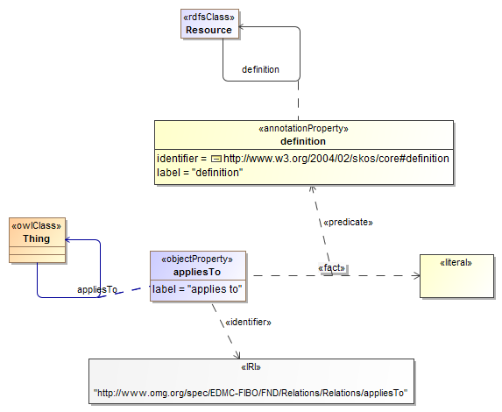

**Figure 3.1 New Object Property in Relations Ontology**

**Table 3.3 Details for the New appliesTo Property**

| **Name** | **Property** | **Definition** | **Concept Type** |
| --- | --- | --- | --- |
| appliesTo | applies to | That to which the thing (typically a mathematical parameter) is applicable, i.e. the thing in respect of which this thing is a parameter or measure or information of some sort | Relationship Property |

### 3.3.2 Changes in Utilities Module

Module metadata updated as shown in Table 3.4.

**Table 3.4 Utilities Module Metadata Changes**

|  |  |
| --- | --- |
| **Metadata Term** | **Value** |
| **sm:moduleVersion** | 1.01 |
| **sm:specificationVersionStatus** | Adopted specification |

#### 3.3.2.1 Changes in Business Facing Types Ontology

Ontology metadata updated as shown in Table 3.5. Addition of two new properties to the ontology BusinessFacingTypes.

**Table 3.5 BusinessFacingTypes Ontology Metadata Changes**

|  |  |
| --- | --- |
| **Metadata Term** | **Value** |
| **owl:versionIRI** | http://www.omg.org/spec/EDMC-FIBO/FND/20140201/Utilities/BusinessFacingTypes/ |
| **sm:priorVersion** | http://www.omg.org/spec/EDMC-FIBO/FND/20130801/Utilities/BusinessFacingTypes/ |
| **skos:changeNote** | This version of the ontology was revised in advance of the March 2014 Reston VA meeting to add the hasPercentageValue and hasNumericValue object properties in support of the IND RFC. |

Figure 3.2 shows the details of the added properties. Table 3.6 shows the properties with their definitions and metadata. Since there were not properties in this ontology before, a new table will need to be added to the specification, for properties.

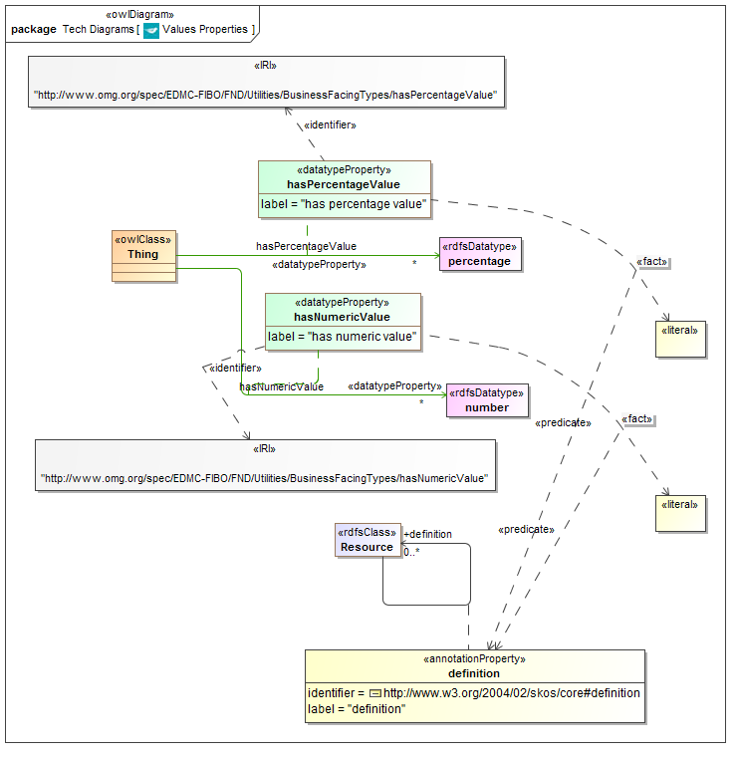

**Figure 3.2 New Diagram and Properties in BusinessFacingTypes**

**Table 3.6 New Properties in BusinessFacingTypes**

| **Name** | **Property** | **Definition** | **Concept Type** |
| --- | --- | --- | --- |
| hasPercentageValue | has percentage value | The value taken by some thing (typically the value taken by some parameter) expressed in percentage terms | Simple Property |
| hasNumericValue | has numeric value | The value taken by some thing (typically the value taken by some parameter) expressed as a number | Simple Property |

#### 3.3.2.2 New Ontology: Math

Added a new ontology to the Utilities module. This has one property and no classes.

**Table 3.7 Math Ontology Metadata**

|  |  |
| --- | --- |
| **Metadata Term** | **Value** |
| **sm:filename** | Math |
| **sm:fileAbbreviation** | fibo-fnd-utl-math |
| **OntologyIRI** | http://www.omg.org/spec/EDMC-FIBO/FND/Utilities/Math/ |
| **owl:versionIRI** | http://www.omg.org/spec/EDMC-FIBO/FND/20140201/Utilities/Math/ |
| **skos:changeNote** | This ontology was added to Foundations in advance of the March 2014 Reston VA meeting in support of the IND RFC. |
| sm:dependsOn | <http://www.omg.org/spec/EDMC-FIBO/FND/Utilities/AnnotationVocabulary/>  <http://www.omg.org/spec/EDMC-FIBO/FND/Utilities/BusinessFacingTypes/> |

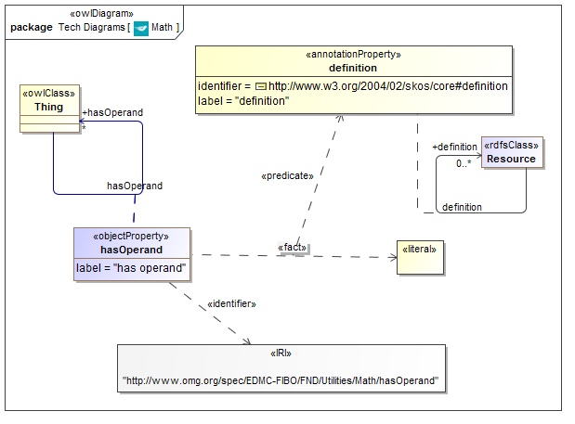

**Figure 3.3 Math Ontology Concepts and Annotations**

**Table 3.8 Math Ontology Properties**

| **Name** | **Property** | **Definition** | **Concept Type** |
| --- | --- | --- | --- |
| hasOperand | has operand | the operand of some mathematical parameter or thing | Relationship Property |

# Terms and Definitions

For the purposes of this specification, the following terms and definitions apply.

**Content**

1. Subject matter or meta-content.

Business conceptual model

1. A model which represents and only represents business subject matter without reference to the design of any solution or data model representation.

Ontology

1. A formalization of a conceptualization. For the purposes of this specification the formalization is in OWL, using ODM as a means to render this, and the conceptualization is that of business subject matter.

**Operational Ontology**

1. An ontology which is intended for use within some application.

**Subject matter**

1. Information about things in the universe of discourse; the essential facts, data, or ideas that constitute the basis of spoken, written, or artistic expression or representation; often : the substance as distinguished from the form especially of an artistic or literary production.

Taxonomy

1. A set of terms which stand in some classification relation to one another.

# Symbols and Abbreviations

## Symbols

There are no symbols introduced by this specification.

## 5.2 Abbreviations

The following abbreviations are used throughout this specification:

* OWL – Web Ontology Language
* ODM – Ontology Definition Metamodel
* RDF – Resource Definition Framework
* SME – Subject Matter Expert
* UML – Unified Modeling Language
* URI – Uniform Resource Identifier
* URL – Uniform Resource Locator
* XMI – XML Metadata Interchange
* XML – eXtensible Markup Language

Additional symbols and abbreviations that are used only in annexes to this specification are given in those annexes.

# Additional Information

## How to Read this Specification

### Audience

This specification has the following audiences:

* The standards community
* The finance industry business community
* The regulatory community
* Technical architects
* Semantic Modelers

#### Standards Community

This audience is intended to be able to follow and validate the way in which this specification sets out the arrangements for the production and maintenance of model content, and the production of business facing reports and diagrams representing parts of that content.

#### The Finance Industry Business Community

As noted in the section on conformance (section 2) this specification includes detailed requirements for the production of diagrams and reports which are intended for consumption by business subject matter experts. This specification also contains material addressed at this audience, this being an informative annex on “Interpreting Model Content”. This audience is not intended to read and understand the remaining parts of this specification.

#### The Regulatory Community

As for Finance Industry Business Community.

#### Technical Architects

These include but are not limited to:

* + Tooling vendors and developers
  + Other content providers / enriched content providers
  + Business Analysts – anyone who use the model on site, whether they are a modeler, a metadata analyst, etc.
  + Technology Management

The bulk of the “Architecture” section is intended to be read and understood by these audiences and by the ‘Semantic Modelers’ audience.

#### Semantic Modelers

Much of the material in this specification is intended to be read and understood by semantic modelers. This includes the 'Conformance' section (Section 2) and the ‘Architecture’ section (Section 8).

## 6.2 Acknowledgements

The following organization submitted this specification:

* Enterprise Data Management Council

The following companies have provided significant expertise and resources in the development of its content and architecture:

* Adaptive Inc.
* Australia and New Zealand Banking Group
* AVOX/DTCC
* Bank of America
* Barclays Capital
* BBH
* Bloomberg
* Business Semantics
* CIBC
* Citigroup Inc.
* Credit Suisse Group AG
* CUSIP
* The Federal National Mortgage Association (Fannie Mae)
* David Frankel Consulting
* FacetApp
* Fidelity
* GoldenSource Corporation
* HSBC Holdings plc
* JPMorgan Chase & Co.
* The Manufacturers Life Insurance Company
* Michigan State University
* Model Driven Solutions
* Model Systems
* Morgan Stanley
* MphasiS
* National Australia Bank
* No Magic
* Nomos Software
* Nordea Bank
* Oakland University
* OntoAge
* OpenFinance
* PricewaterhouseCoopers LLP
* Revelytix
* Sallie Mae
* SAP
* Semantic Arts
* State Street
* Sungard
* SWIFT
* Tahoe Blue
* Thematix Partners LLC
* Thomson Reuters
* UBS AG
* University of British Columbia
* University College Cork
* Wells Fargo
* Wizdom Systems, Inc.

## 6.3 Interpreting the Business Model Content

**Intended Audiences***: Business Subject Matter experts*

### 6.3.1 Introduction

The model content is intended by read and understood by business domain experts with knowledge of market indices and indicators. It requires no knowledge of modeling theory, technical modeling languages, technology development or data modeling.

The following knowledge is required to interpret the model content:

* Set theory
* Logic
* Business (commerce, law, finance, investment, derivatives trading)

### 6.3.2 The Model

#### 6.3.2.1 What the Model Contains

The model described in this specification contains elements called 'Things', Simple Properties about those things in the form of unstructured information, and Relationship Properties in the form of relationships between one 'Thing' and another. Things, Simple Properties and Relationship Properties all have as a minimum the definition for the term that they represent, plus additional information on usage, review history, sources of terms and definitions and so forth.

#### 6.3.2.2 Model Views

Whereas the information given in this specification conveys all of the model content, the diagrams and tables that are created for a business audience will not show all of this information, but only a sub-set. This sub clause describes those formats and views, and is to be read by a business audience to understand what those views show. This sub clause contains no technical language about OWL or other modeling constructs but uses the plain English alternative terms for those concepts.

The content of the model is rendered in two basic forms: visual information in the form of diagrams, and textual information in the form of tables. The diagrams are available in varying levels of detail and are created to show different sets of terms and relationships across or within sections of the model. The textual information is created as web based tabular reports and as spreadsheets. These contain basic information of term, definition and synonym and in some cases will contain additional information about the types of thing or the types of information to which facts in the model refer. Business tables and spreadsheets do not show relationships between relationships as such information would be difficult to visualize in the tabular format.

Diagrams and tables reflect the information retained in the underlying model repository directly. For example, if two 'Thing' elements have a relationship between them and they appear on the same diagram, the relationship between them will always appear.

#### 6.3.2.3 Business Diagrams

Business diagrams reflect any set of terms in the model, within or across sections of the content. These may be rendered with varying levels of detail. Diagrams created during reviews of the subject matter will typically contain a greater range of terms than diagrams created for presentation to the wider community of potential users.

### 6.3.3 Interpretation

The model conveys 'Things' and 'Facts' (properties). Properties are in two forms:

* 'Simple Properties': these are a statement about something which is framed in terms of some simple type of information, such as textual entries, yes/no answers, dates, numbers and selections of textual information
* 'Relationship Properties': these are a statement about something which is framed in terms of something else, that other thing also being framed as a kind of 'Thing'.

In addition, there are relationships which represent additional set theory concepts, notably logical unions, mutual exclusivity.

Each 'Thing' also has a 'Parent' relationship, with the sense of 'is a', shown as an upward point arrow on the diagrams. This relationship indicates that the thing from the non-arrowed end is “a kind of” the thing at the end with the arrow.

These concepts are described in the sections which follow.

#### 6.3.3.1 Thing

A Thing is a set theory construct. This is shown on the diagrams as a box with a name. On some diagrams, additional textual entries in the box show the Simple Properties about that thing.

A Thing is defined as the set of individuals which are defined according the facts (properties) given for that kind of thing. Membership of the set is defined in the sense that any individual in the world of which the stated facts are true or applicable, is a member of that set. In terms of logical theory, these sets are defined intensionally. It is also possible to define a set explicitly as a list of its members (in logical theoretic terms, an extensional definition) but this is not used in practice in the model.

#### 6.3.3.2 Inheritance: the Parent 'is a' relationship

Each Thing in the model has one or more parent Things. The relationship between the Thing and its parent may be interpreted as an 'is a' form of relationship, meaning that the thing of which the parent relationship is shown is a kind of the thing to which the arrow in the Parent relationship is pointing.

This relationship formally indicates that the thing that has the Parent, inherits all of the facts about that parent. In addition, this relationship is transitive, meaning that the parent relationships of the parent are passed on to the child term. For example, if a share is a security and a security is a transferable contract then a share is a transferable contract.

The relationships of this type create a formal inheritance structure called a Taxonomy. Taxonomies in this sense may be single inheritance (as is often seen in technical model designs) or multiple inheritance. In the FIBO models these are multiple inheritance, meaning that types of thing (such as types of contract) may be classified in more than one way. So for example an interest rate swap is both a swap and an interest rate derivative.

As an example of multiple inheritance, one might say that in terms of the Linnaeus Taxonomy of Species, a whale is a mammal, while one may also create a set of taxonomic classifications based on habitat, in terms of which a whale may also be a marine animal.

On a technical note, the Parent relationship is functionally identical to the relationship known as 'Generalization' in the UML modeling language.

#### 6.3.3.3 Simple Properties

Simple Properties are assertions about things in a class, which may be framed in terms of some simple type of information.

Types of information about which Simple Properties are asserted are:

* Text
* Date
* Number
* Whole number
* Yes/no answer
* Selection of textual descriptors

To a technical person these may easily be identified with what are called 'datatypes'. However these represent the types of information not data as such. A special case is the selection of possible answers - this refers to a list of entries (see Selection Lists).

#### 6.3.3.4 Relationship Properties

A Relationship Property is defined as a fact about something which is framed in terms of a relationship to some other thing.

These are indicated on the diagrams as a blue arrowed line. Some diagrams additionally show a box attached to this blue line; this is used to indicate relationships between those Relationship Properties, which are shown as lines between those boxes.

Relationship Properties are of the form subject-relationship-object where the subject is the Thing from which the line is drawn and the object is the thing to which the blue arrow points.

The label on the line is the verb itself, while the attached box indicates the full name of the Relationship Property. Relationship Properties are unique across the model and each belongs to one Thing only.

There are additional pieces of information about these Relationship Properties, such as whether they are symmetric, transitive and so on. The use and interpretation of these refinements to Relationship Properties are beyond the scope of this explanatory sub clause.

#### 6.3.3.5 Logical Unions

Logical unions indicate that any individual which is a member of any of the classes of 'Thing' of which the union is a union, are members of that union.

The Union is shown as a box on the diagrams, similar to the boxes used for classes of 'Thing' but without the coloring given for archetypes (no Union has an archetype), that is these have the default gold box appearance of an OWL Class.

Membership of the union is indicated by a purple relationship similar in appearance to the Parent / 'is a' relationship. The Union (set) shown at the top of the arrow is thereby indicated as being a logical union of all the sets indicated as classes of Thing at the bottom of the purple arrows.

Relationship Properties may refer to unions in the same way that they refer to other classes of Thing.

#### 6.3.3.6 Mutually Exclusive sets

Given that each thing is a set of potential members defined by their properties (facts), it is possible for any one thing in the world to be defined as being a member of more than one set, if the properties asserted for one set are not related to the properties asserted for another set.

Where membership of one set necessarily precludes membership of another set (that is, where a set is defined such as to specifically exclude members of another set), this is shown by a red line on the diagrams, labeled 'mutually exclusive'.

Where classes of 'Thing' are not indicated as being mutually exclusive (or have parents which belong to classes of Thing which are mutually exclusive), then any individual in the domain of discourse (the world) may belong to both sets.

This is formally known as a 'disjoint' relationship.

#### 6.3.3.7 Relationship Properties hierarchies

Relationship Properties are themselves disposed in a hierarchy similar to that given for the classes of 'Thing'. These are indicated on more advanced diagrams by a green upward pointing line in the same style as the Parent relationship line. The Relationship Property to which the arrow points represents a more general meaning, of which the Relationship Property at the bottom of the relationship represents a narrower definition of the same meaning.

The narrowing of these meanings frequently occurs in conjunction with the narrowing of the meanings of classes of 'Thing' in the taxonomy. For example, types of bond are classified (a narrowing or specialization of the meaning of 'bond') according to, among other things, a narrowing of the relationship 'issued by' with the latter relationships being distinguished form one another by the nature of the kind of party which is the issuer.

This is formally known as a “sub property of' relationship.

#### 6.3.3.8 Inverse relationships

These are only shown on diagrams that show the Relationship Properties with their boxes, i.e. diagrams that show relationships between relationships.

Relationship Properties in the model are all one-directional, by virtue of their being framed as 'subject-verb-object' triples. In the business domain, meaningful terms and definitions may exist in either direction between one class of thing and another (for example, a bank has a customer versus a person has an account at the bank.

These are indicated as a red dotted arrowed line between one relationship and the relationship to which it is the inverse.

In theoretical terms, this relationship only applies between relationships which are known as 'functional' relationships. An explanation of this is beyond the scope of this sub clause.

#### 6.3.3.9 Selection Lists

A list of possible entries for a simple type is displayed as a box on the diagrams, with a list of the possible entries. These are displayed as text, and generally refer to lists of possible textual values for the Simple Property.

It should be noted that these do not or should not represent lists of kinds of 'Thing' - those would be represented as a taxonomy of actual things. This is an important difference between this and a data model, since many data models have similar selection lists, called 'enumerations' in the data modeling world, which may represent kinds of thing or classifications of the thing which has these as a property.

#### 6.3.3.10 Selections of Things

This is a class or set of things of which the members are explicitly listed (in theoretical terms, an extensional definition of the class).

These are not used at present in the model but are provided for in the modeling notation.

#### 6.3.3.11 Restrictions

A restriction is a way of describing a set of things based on their having specific classes of thing participating in a nominated property (identified by an “on property” relation). The restriction may be based on how many of that class of thing they must have for the property (known as “cardinality”), for example “at least two of something participate in the relationship *involved party*” and optionally on the type of those things (for example “at least two of something participate in the relationship *involved party* and these may only be taken from *legal person*”).

Alternatively, the restriction may be framed in terms of whether all participants in the relationship must be a certain type of thing (labeled as “with only”); or in terms of whether out of all such relationships, there must be some (one or more) which are of a certain type of thing (labelled as “with some”). For example the restriction “there must be at least one thing in the relationship *involved party* that is a *Corporation*” would be framed using a “with some” restriction.

A restriction is applied to a type of thing in one of two ways:

* The restriction is necessary to qualify for membership of the type. For example the type *Foo* *Corporation* could have a necessary restriction on property *executive officer* such that there must be at least two things participating in that relationship which are of the type *Natural Person*. This is not sufficient though – many other types of entity could also have executive officers that are natural persons. This is depicted using “subclass”.
* The restriction is sufficient to qualify for membership of the type. For example the type Shareholder could have a sufficient restriction on property *assets owned* such that there must be at least one thing in this relationship which is of type *Corporate Equity.* That means that mere possession of an equity instrument is enough to qualify as a Shareholder. Sufficient does also imply necessary. This is depicted using “equivalent to”.

There is a special case of the “cardinality” type of restriction - “at least 0” - which is used to indicate that the set of things is expected to make use of the property but there is no requirement for it to be there.

Finally, a restriction itself represents a set, or type of thing, so it can itself be further restricted. For example if we wanted to ensure that the executive officers for *Foo Corporation* have a masters degree we might recast the restriction above to be a restriction on property *has* *executive officer* such that there must be at least two occurrences of this relationship which themselves are subject to another restriction, which is: {the restriction on property *has degree* so that it has at least one occurrence where it is of the type *Masters Degree*}.

# Introduction

## Audiences

Readers are encouraged to read Section 6.1 on the different intended audiences for this standard.

### 7.1.1 Audience for this Section

The audience for this section is anyone who wishes to understand this standard, whether from a business or technical standpoint.

### 7.1.2 Reading this Standard

Technical audiences (in both conventional and semantic technology) are directed at the “Architecture” section (Section 8).

Business audiences (financial industry participants, regulators and others) are directed at this Introduction and at Annex A on interpreting model content (Annex B).

The business content defined in this standard is intended to be presented both in a business-facing format and in a complete, technical format. The latter is intended for consumption by technical and standards audiences only. This specification defines the content of the standard and the ways in which it is to be presented to business readers.

## Specification Overview

### 7.2.1 Non Technical Overview

**Audience:** Business.

This specification provides a model of financial market indices and economic indicators terms, definitions and relationships. The model contains no technical design content and is a representation of the indices and indicators concepts. This specification describes the technical arrangements by which this has been brought about, the requirements to be placed upon semantic modelers who are to extend this content locally or to propose updates to the model, and the requirements by which the content of this and future extensions are to be presented to business domain participants, so that they may understand and review the model content without the need for any formal technical training.

### 7.2.2 Technical Overview

**Audience:** Technical architects.

The model content is developed and maintained using the Unified Modeling Language as a modeling tool framework, but with all model content built using the formal constructs of the Web Ontology Language (OWL). This is achieved using the OMG's Ontology Definition Metamodel (ODM) specification.

The use of the ODM specification in this specification is limited to a specific sub-set of OWL constructs, and is also limited to the range of UML base classes that is allowed for each of the OWL constructs that are used, as defined in the [FIBO Foundations] specification.

The model content is made available as serialized ODM UML in the form of XMI files (“ODM XMI”, as serialized UML in the form of XMI files (“UML XMI”) and as OWL files in the RDF/XML syntax. The deliverables are described in Annex A.

## 7.3 Business Usage Scenarios

### 7.3.1 Indices and Indicators Usage Scenarios

A number of business scenarios are supported by this specification. These include:

* Formal definitions and concepts for market indices and economic indicators for reference in integration
* Index and indicator terms for the definition of derivatives contracts
* Development of semantic models (ontologies) of derivatives contracts which have indices, indicators or interest rates as their underlying variables – ontologies for those contracts whether developed privately or as future FIBO specifications, would semantically import the concepts in this specification.
* Risk applications including credit risk, market risk.

# Architecture

**Intended Audiences:** Technologists, Semantic Technologists, Standards Implementers.

## 8.1 Overview

The architecture of FIBO is described in the [FIBO Foundations] specification.

Please also refer to the Scope section (Section 1) and the Definitions (Section 4) for detailed treatment of the terms and concepts referred to.

## 8.2 The Foundations Models

This specification makes reference to specific sets of terms in the [FIBO Foundations] specification.

As a consequence of the modeling principles, the model requires ontologies of things which are not specific to indices and indicators. The Foundations ontologies include legal concepts like contracts, business concepts such as service provision, as well as an extensive set of concepts for times, dates, mathematical constructs, events and activities, and so on. FIBO Indices and Indicators draws extensively on abstractions for numeric amounts and values as well as concepts in the area of business entities drawn from the [FIBO BE] Business Entities specification, to describe publishers of indicators, interest rates and economic indicators.

These terms are maintained in the material described in the [FIBO Foundations] specification and the [FIBO BE] specification.

## 8.3 Ontology Architecture and Namespaces

As described in the FIBO Foundations specification in section 8.2, the ontology architecture for FIBO is designed to facilitate reuse and ontology evolution to the degree possible. An approach to the foundational terminology, including basic terminology describing amounts and rates, that provides very high-level, abstract conceptual knowledge designed to facilitate mapping is an important design goal. The basic building blocks for the Indices and Indicators (IND) Ontology, building on the architecture provided in Foundations, are shown in Figure 8.1, below.

As shown in the diagram, the IND ontologies are divided up into a number of *modules*. These include: Indicators (concepts common to more than one type of index or indicator), Foreign Exchange Rates, Interest Rates and Market Indicators.

The IND modules will ultimately depend on (1) Basic Terminology and Ontology Metadata (in light gray in the figure), (2) Foundations, (3) Business Entities and (4) a number of external modules, representing concepts for Natural Language, Geopolitical Entities (for example ISO 3166 Country codes, regional and municipal designations), and concepts defining dates, times, and durations. A sample set of these anticipated external resources are given in the dark gray layer in the figure.

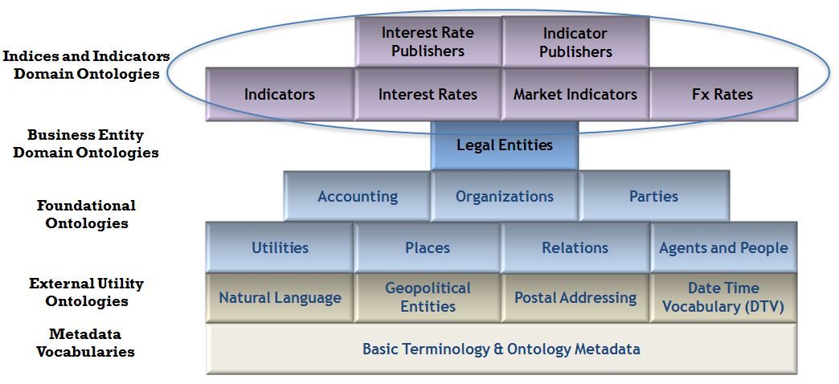

Figure 8.1 Indices and Indicators Ontology Architecture

The namespaces and their well-known prefixes corresponding to external elements required for use of FIBO Indices and Indicators include all of those listed in the FIBO Foundations specification and selected terms from the FIBO Business Entities specification, as well as those required for the use of Foundations itself. Table 8.1 lists those prefixes and namespaces considered external to Foundations. Table 8.2 provides those required for use of Foundations while Table 8.3 provides those required for use of the Business Entities specification (repeated here for convenience).

Table 8.1 Prefix and Namespaces for referenced/external vocabularies

|  |  |  |
| --- | --- | --- |
| Namespace Prefix | | Namespace |
| **rdf** | **http://www.w3.org/1999/02/22-rdf-syntax-ns#** | |
| **rdfs** | http://www.w3.org/2000/01/rdf-schema# | |
| **owl** | http://www.w3.org/2002/07/owl# | |
| **xsd** | http://www.w3.org/2001/XMLSchema# | |
| **dct** | http://purl.org/dc/terms/ | |
| **skos** | http://www.w3.org/2004/02/skos/core# | |
| **sm** | http://www.omg.org/techprocess/ab/SpecificationMetadata/ | |

Table 8.2 Prefix and Namespaces for FIBO Foundations

| Namespace Prefix | Namespace |
| --- | --- |
| **fibo-fnd-acc-aeq** | http://www.omg.org/spec/EDMC-FIBO/FND/Accounting/AccountingEquity/ |
| **fibo-fnd-acc-cur** | http://www.omg.org/spec/EDMC-FIBO/FND/Accounting/CurrencyAmount/ |
| **fibo-fnd-aap-agt** | http://www.omg.org/spec/EDMC-FIBO/FND/AgentsAndPeople/Agents/ |
| **fibo-fnd-aap-ppl** | http://www.omg.org/spec/EDMC-FIBO/FND/AgentsAndPeople/People/ |
| **fibo-fnd-agr-agr** | http://www.omg.org/spec/EDMC-FIBO/FND/Agreements/Agreements/ |
| **fibo-fnd-agr-ctr** | http://www.omg.org/spec/EDMC-FIBO/FND/Agreements/Contracts/ |
| **fibo-fnd-gao-gl** | http://www.omg.org/spec/EDMC-FIBO/FND/GoalsAndObjectives/Goals/ |
| **fibo-fnd-gao-obj** | http://www.omg.org/spec/EDMC-FIBO/FND/GoalsAndObjectives/Objectives/ |
| **fibo-fnd-law-jur** | http://www.omg.org/spec/EDMC-FIBO/FND/Law/Jurisdiction/ |
| **fibo-fnd-law-lcap** | http://www.omg.org/spec/EDMC-FIBO/FND/Law/LegalCapacity/ |
| **fibo-fnd-law-cor** | http://www.omg.org/spec/EDMC-FIBO/FND/Law/LegalCore/ |
| **fibo-fnd-org-fm** | http://www.omg.org/spec/EDMC-FIBO/FND/Organizations/FormalOrganizations/ |
| **fibo-fnd-org-lg** | http://www.omg.org/spec/EDMC-FIBO/FND/Organizations/LegitimateOrganizations/ |
| **fibo-fnd-org-org** | http://www.omg.org/spec/EDMC-FIBO/FND/Organizations/Organizations/ |
| **fibo-fnd-oac-ctl** | http://www.omg.org/spec/EDMC-FIBO/FND/OwnershipAndControl/Control/ |
| **fibo-fnd-oac-own** | http://www.omg.org/spec/EDMC-FIBO/FND/OwnershipAndControl/Ownership/ |
| **fibo-fnd-pty-pty** | http://www.omg.org/spec/EDMC-FIBO/FND/Parties/Parties/ |
| **fibo-fnd-pty-rl** | http://www.omg.org/spec/EDMC-FIBO/FND/Parties/Roles/ |
| **fibo-fnd-plc-adr** | http://www.omg.org/spec/EDMC-FIBO/FND/Places/Addresses/ |
| **fibo-fnd-plc-cty** | http://www.omg.org/spec/EDMC-FIBO/FND/Places/Countries/ |
| **fibo-fnd-plc-loc** | http://www.omg.org/spec/EDMC-FIBO/FND/Places/Locations/ |
| **fibo-fnd-rel-rel** | http://www.omg.org/spec/EDMC-FIBO/FND/Relations/Relations/ |
| **fibo-fnd-utl-av** | http://www.omg.org/spec/EDMC-FIBO/FND/Utilities/AnnotationVocabulary/ |
| **fibo-fnd-utl-bt** | http://www.omg.org/spec/EDMC-FIBO/FND/Utilities/BusinessFacingTypes/ |

Table 8.3 Prefix and Namespaces for FIBO Business Entities

|  |  |
| --- | --- |
| Namespace Prefix | Namespace |
| **fibo-be-oac-cpty** | **http://www.omg.org/spec/EDMC-FIBO/BE/OwnershipAndControl/ControlParties/** |
| **fibo-be-le-cb** | **http://www.omg.org/spec/EDMC-FIBO/BE/LegalEntities/CorporateBodies/** |
| **fibo-be-oac-cctl** | **http://www.omg.org/spec/EDMC-FIBO/BE/OwnershipAndControl/CorporateControl/** |
| **fibo-be-oac-cown** | **http://www.omg.org/spec/EDMC-FIBO/BE/OwnershipAndControl/CorporateOwnership/** |
| **fibo-be-corp-corp** | **http://www.omg.org/spec/EDMC-FIBO/BE/Corporations/Corporations/** |
| **fibo-be-le-fbo** | **http://www.omg.org/spec/EDMC-FIBO/BE/LegalEntities/FormalBusinessOrganizations/** |
| **fibo-be-oac-exec** | **http://www.omg.org/spec/EDMC-FIBO/BE/OwnershipAndControl/Executives/** |
| **fibo-be-fct-fct** | **http://www.omg.org/spec/EDMC-FIBO/BE/FunctionalEntities/FunctionalEntities/** |
| **fibo-be-le-lp** | **http://www.omg.org/spec/EDMC-FIBO/BE/LegalEntities/LegalPersons/** |
| **fibo-be-le-lei** | **http://www.omg.org/spec/EDMC-FIBO/BE/LegalEntities/LEIEntities/** |
| **fibo-be-oac-opty** | **http://www.omg.org/spec/EDMC-FIBO/BE/OwnershipAndControl/OwnershipParties/** |
| **fibo-be-ptr-ptr** | **http://www.omg.org/spec/EDMC-FIBO/BE/Partnerships/Partnerships/** |
| **fibo-be-tr-tr** | **http://www.omg.org/spec/EDMC-FIBO/BE/Trusts/Trusts/** |

As described in the [FIBO Foundations] specification, the namespace approach taken for FIBO is based on OMG guidelines and is constructed as follows:

* A standard prefix http://www.omg.org/spec/
* The family name, EDMC-FIBO
* The abbreviation for the specification: in this case IND
* The module name
* The ontology name

Note that the URI/IRI strategy for the ontologies in FIBO takes a “slash” rather than “hash” approach, in order to accommodate server-side applications. Though not technically necessary, this specification does mandate namespace prefixes to be used. These are constructed as follows with the components separated by “-“:

* The specification family name fibo
* The specification abbreviation: ind
* An abbreviation for the module name
* An abbreviation for the ontology name

The namespaces and prefixes corresponding to FIBO Indices and Indicators ontologies are summarized in Table 8.4 for convenience. These are given in alphabetical order, by module, rather than with any intent to show imports relationships.

Table 8.4 Prefix and Namespaces for FIBO Indices and Indicators

|  |  |
| --- | --- |
| Namespace Prefix | Namespace |
| **fibo-ind-ind-par** | **http://www.omg.org/spec/EDMC-FIBO/IND/Indicators/IndicatorsParameters/** |
| **fibo-ind-fx-fxr** | **http://www.omg.org/spec/EDMC-FIBO/IND/FxRates/ForeignExchange/** |
| **fibo-ind-ir-ir** | **http://www.omg.org/spec/EDMC-FIBO/IND/InterestRates/InterestRates/** |
| **fibo-ind-ir-pub** | **http://www.omg.org/spec/EDMC-FIBO/IND/InterestRates/InterestRatePublishers/** |
| **fibo-ind-mei-mei** | **http://www.omg.org/spec/EDMC-FIBO/IND/MarketIndicators/MarketIndicators/** |
| **fibo-ind-mei-pub** | **http://www.omg.org/spec/EDMC-FIBO/IND/MarketIndicators/IndicatorPublishers/** |
| **fibo-ind-inx-bsi** | **http://www.omg.org/spec/EDMC-FIBO/IND/MarketIndices/BasketIndices/** |
| **fibo-ind-inx-dri** | **http://www.omg.org/spec/EDMC-FIBO/IND/MarketIndices/CreditIndices/** |
| **fibo-ind-inx-pub** | **http://www.omg.org/spec/EDMC-FIBO/IND/MarketIndices/BasketIndexPublishers/** |

# 9 Model Content Reports

## 9.1 Overview

This section lists all the terms, definitions and relationships in the Indices and Indicators models defined in this specification.

Please note that this section is not intended to be read by business subject matter experts; for this purpose, tabular reports or spreadsheets should be produced for this audience as described elsewhere in this specification.

### 9.1.1 Interpreting This Section

This section shows each of the components of the model with their OWL construct names where applicable. These are:

| **Construct Name** | **Description** |
| --- | --- |
| **Module:** | A grouping of ontologies with some common theme. These also share a namespace fragment in the corresponding OWL files. |
| **Ontology** | A single OWL ontology. |
| **Class of Thing** | An OWL Class, that is a set theoretic construct representing a common set of properties, possession of which would make any individual a member of this set. |
| **Relationship property** | The Class named as “Range” for the relationship represents something in terms of which the meaning of the relationship is framed.  Known as “object property” in OWL. |
| **Parent** | **“is a”** relationships - these have no definition. This relationship indicates that the Class is a sub-class of the Class to which the relationship is pointing. |
| **Simple property** | Some property framed in terms of some simple type of information such as text or a “yes or no” value.  Known as “datatype property” in OWL. |
| **Datatype Property Range** | The type of information in which the OWL Datatype Property is framed  Known as “Type” in the tables, where one column combines types of simple properties, and related things (ranges) of relationship properties  NOTE: for some simple properties, the range is a DataEnumeration (see below). |
| **Data Enumeration** | These item represent a selection of possible values, which are intended to be taken as literal (e.g. textual) values. A “Simple property” (OWL Datatype Property) may identify one of these as the Simple property Type; this means that any one of the values in the list may be a possible value for this property. |
| **Logical Union** | A logical union of Classes. The membership of the union is shown in this report in the “Related thing or type” column. |
| **Mutually exclusive** | Identifies two sets of which no one individual may be a member of both.  Known as “disjoint” in OWL. |
| **Definition** | The SKOS Definition annotation, giving the formal definition of the item |
| **Explanatory Note** | An annotation giving more detailed business facing explanations for concepts. |
| **Editorial Note** | The SKOS Editorial Note annotation, giving additional editorial narrative about the term and definition. |
| **Term Origin** | The origin of the concept in some external source, which was directly used as a point of reference in deriving the concept indicated. |
| **Definition Origin** | The origin of the written definition for the concept in some external source, which was directly used as a point of reference in deriving the concept indicated. |
| **Restriction** | A set theoretic construct representing the re-use or refinement of an existing relationship property. The restriction represents a set of things in the business domain, the set being everything which has the stated relationship restricted as shown. Restrictions may be a super-class of some class of thing (representing a necessary condition for membership of that class) or they may be shown as “equivalent to” that class of thing, meaning that the restriction represents necessary and sufficient conditions for membership of that class. |

## 9.2. Module: Indicators

Table 9.1 Indicators Module Metadata

|  |  |
| --- | --- |
| **Metadata Term** | **Value** |
| **sm:moduleName** | Indicators |
| **sm:moduleAbbreviation** | FIBO-IND-IND |
| **sm:moduleVersion** | 1.0 |
| **sm:moduleAbstract** | This module includes ontologies for concepts common to all types of market index and market indicator or economic measure. These are all types of numeric parameter which vary over time, and are published by some source. These are divided into concepts descriptive of the numeric parameter, and concepts descriptive of the values which those parameters take over time. |

### 9.2.1 Ontology: Indicators Parameters

This ontology provides the concepts common to all market rates, indices and indicators; that is concepts descriptive of the numeric parameters themselves. These are modeled independently of the values they may take over time.

Table 9.2 Indicators Parameters Ontology Metadata

| **Metadata Term** | **Value** |
| --- | --- |
| **sm:filename** | Indicators Parameters |
| **sm:fileAbbreviation** | fibo-ind-ind-par |
| **OntologyIRI** | http://www.omg.org/spec/EDMC-FIBO/IND/Indicators/IndicatorsParameters/ |
| **owl:versionIRI** | http://www.omg.org/spec/EDMC-FIBO/IND/20140201/Indicators/IndicatorsParameters/ |
| **sm:dependsOn** | http://www.omg.org/techprocess/ab/SpecificationMetadata/  http://www.omg.org/spec/EDMC-FIBO/FND/Utilities/AnnotationVocabulary/ |

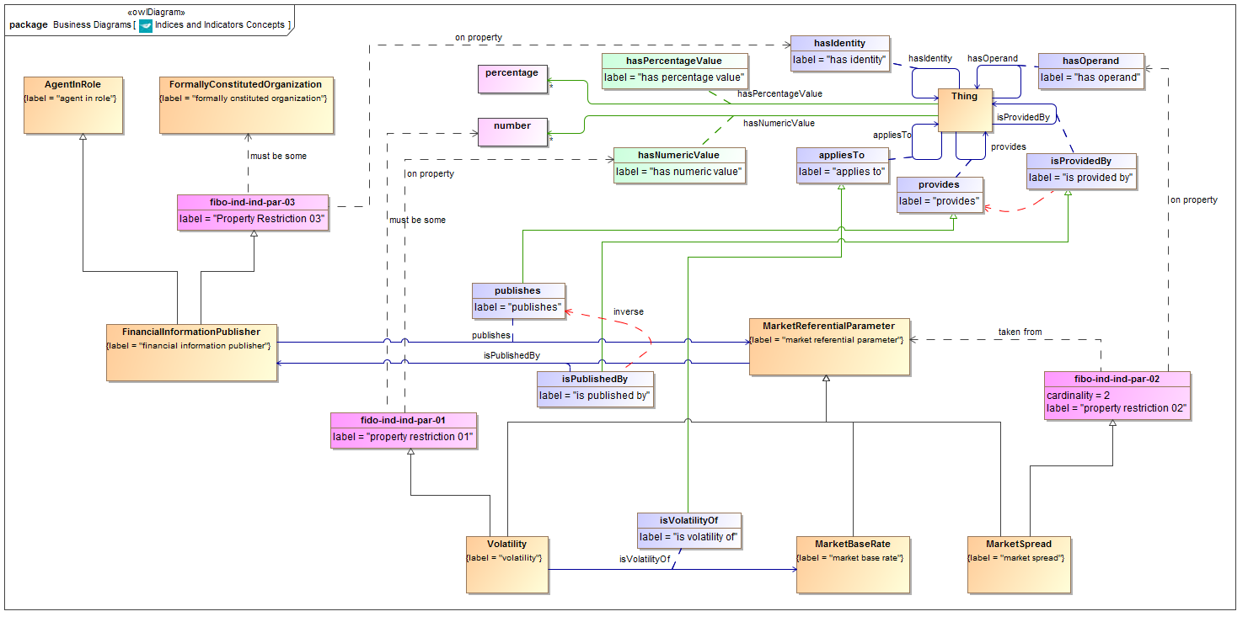

**Figure 9.1 Indicators Parameters Concepts**

Diagram showing all of the concepts in the Indicators Parameters ontology.

Table 9.3 Indicators Parameters Details

| **Concept Type** | **Name** | **Type Of Thing** | **Property** | **Definition** | **Parent** | **Mutually Exclusive With** | **Related Thing or Type** | **Inverse Of Property** | **Multiples** | **Editorial Note** | **Explanatory Note** | **Term Origin** | **Definition Source** |
| --- | --- | --- | --- | --- | --- | --- | --- | --- | --- | --- | --- | --- | --- |
| Class | Volatility | volatility |  | A measure of security price fluctuation. Mathematically the volatility is the annualized standard deviation of a security's daily price changes | market referential parameter property restriction 01 |  |  |  |  |  |  |  |  |
| Class | MarketSpread | market spread |  | A published figure giving the difference (known as the spread) between two different market rates. | market referential parameter property restriction 02 |  |  |  |  |  |  |  |  |
| Class | MarketReferentialParameter | market referential parameter |  | A published parameter about financial or other markets, such as an index, an indicator or an interest rate. |  |  |  |  |  |  |  |  |  |
| Class | MarketBaseRate | market base rate |  | Calculated notional value used to measure market trends for a set of instruments (S&P500, NASDAQ composite, 30day CD) or express economical climate for an industry (DowJones Industrial, H&Q Growth Technologies) and/or political region (Libor, Prime) | market referential parameter |  |  |  |  |  | Calculated notional value used to measure market trends for a set of instruments. Includes regions, economies, and so on. Hence sub sets for different types of market bases. |  |  |
| Class | FinancialInformationPublisher | financial information publisher |  | Some entity acting in the capacity of a publisher or provider of information which is related to the financial markets, or which is of interest to financial market participants such as information on economies. | agent in role Property Restriction 03 |  |  |  |  |  |  |  |  |
| Relationship Property | publishes | financial information publisher | publishes | Makes information publicly available in the form of some market referential paramater including economic indices, investment indices and economic indicators. | provides |  | market referential parameter | is published by |  |  |  |  |  |
| Relationship Property | isVolatilityOf | volatility | is volatility of | The market rate to which the volatility measure applies and of which it is a measure. | applies to |  | market base rate |  |  |  |  |  |  |
| Relationship Property | isPublishedBy | market referential parameter | is published by | That which is acting in the role of publisher of this information, being some entity which makes this information available to the publc by some means. | is provided by |  | financial information publisher | publishes |  |  |  |  |  |
| Property Restriction | fido-ind-ind-par-01 | property restriction 01 | has numeric value | Set of things with the property shown, where at least one participant in that relationship must be taken from the type of thing indicated. |  |  | number |  | must be some |  |  |  |  |
| Property Restriction | fibo-ind-ind-par-02 | property restriction 02 | has operand | Set of things that have the property shown, in the multiples given, taken from the type of thing indicated. |  |  | market referential parameter |  | equals 2 |  |  |  |  |
| Property Restriction | fibo-ind-ind-par-03 | Property Restriction 03 | has identity | Set of things with the property shown, where at least one participant in that relationship must be taken from the type of thing indicated. |  |  | formally constituted organization |  | must be some |  |  |  |  |

## 9.3 Module: Fx Rates

Table 9.4 Fx Rates Module Metadata

|  |  |
| --- | --- |
| **Metadata Term** | **Value** |
| **sm:moduleName** | FxRates |
| **sm:moduleAbbreviation** | FIBO-IND-FX |
| **sm:moduleVersion** | 1.0 |
| **sm:moduleAbstract** | This module includes ontologies defining concepts to do with foreign exchange. |

### 9.3.1 Ontology: Foreign Exchange

This ontology provides the parameters for foreign exchange rates, covering spot and forward rates, as well as Fx spot rate volatilities.

Table 9.5 Foreign Exchange Ontology Metadata

|  |  |
| --- | --- |
| **Metadata Term** | **Value** |
| **sm:filename** | ForeignExchange |
| **sm:fileAbbreviation** | fibo-ind-fx-fxr |
| **OntologyIRI** | http://www.omg.org/spec/EDMC-FIBO/IND/FxRates/ForeignExchange/ |
| **owl:versionIRI** | http://www.omg.org/spec/EDMC-FIBO/IND/20140201/FxRates/ForeignExchange/ |
| **sm:dependsOn** | http://www.omg.org/techprocess/ab/SpecificationMetadata/  http://www.omg.org/spec/EDMC-FIBO/FND/Utilities/AnnotationVocabulary/ |

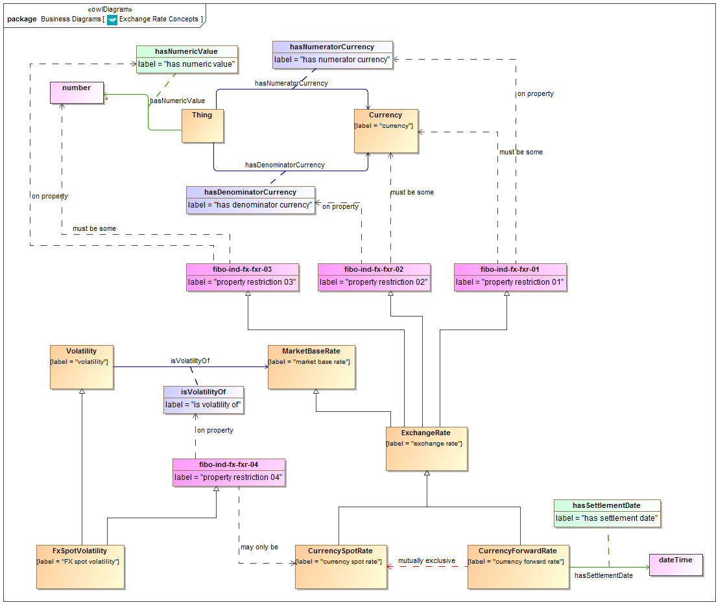

**Figure 9.2 Foreign Exchange Concepts**

Diagram showing all of the concepts in the Foreign Exchange ontology.

Table 9.6 Foreign Exchange Details

| **Concept Type** | **Name** | **Type Of Thing** | **Property** | **Definition** | **Parent** | **Mutually Exclusive With** | **Related Thing or Type** | **Inverse Of Property** | **Multiples** | **Editorial Note** | **Explanatory Note** | **Term Origin** | **Definition Source** |
| --- | --- | --- | --- | --- | --- | --- | --- | --- | --- | --- | --- | --- | --- |
| Class | FxSpotVolatility | FX spot volatility |  | A measure of exchange rate fluctuation. Mathematically the volatility is the annualized standard deviation of the daily changes in the exchange rate, | volatility property restriction 04 |  |  |  |  |  |  |  |  |
| Class | ExchangeRate | exchange rate |  | A rate of exchange between two currencies, expressed as the ratio between a number of units of the numerator currency to one unit of the denominator currency. | property restriction 01 property restriction 02 property restriction 03 market base rate |  |  |  |  |  |  |  |  |
| Class | CurrencySpotRate | currency spot rate |  | The exchange rate at a point in time, with settlement at that same point in time. | exchange rate | currency forward rate |  |  |  |  |  |  |  |
| Class | CurrencyForwardRate | currency forward rate |  | The rate of exchange between the two currencies, expressed as a ratio of number of units of the numerator to one unit of the denominator currency, for settlement at some future point in time. | exchange rate | currency spot rate |  |  |  |  |  |  |  |
| Simple Property | hasSettlementDate | currency forward rate | has settlement date | The date for forward settlement of currency transactions at this forward exchange rate. |  |  | xsd:dateTime |  |  |  |  |  |  |
| Relationship Property | hasNumeratorCurrency |  | has numerator currency | The currency used as the numerator of the exchange rate. R units of this currency represent one unit of the denominator currency. |  |  | currency |  |  |  |  |  |  |
| Relationship Property | hasDenominatorCurrency |  | has denominator currency | The currency used as the denominator of the exchange rate. One unit of this currency represents R units of the numerator currency, where R is the Exchange Rate value. |  |  | currency |  |  |  |  |  |  |
| Property Restriction | fibo-ind-fx-fxr-01 | property restriction 01 | has numerator currency | Set of things with the property shown, where at least one participant in that relationship must be taken from the type of thing indicated. |  |  | currency |  | must be some |  |  |  |  |
| Property Restriction | fibo-ind-fx-fxr-02 | property restriction 02 | has denominator currency | Set of things with the property shown, where at least one participant in that relationship must be taken from the type of thing indicated. |  |  | currency |  | must be some |  |  |  |  |
| Property Restriction | fibo-ind-fx-fxr-03 | property restriction 03 | has numeric value | Set of things with the property shown, where at least one participant in that relationship must be taken from the type of thing indicated. |  |  | number |  | must be some |  |  |  |  |
| Property Restriction | fibo-ind-fx-fxr-04 | property restriction 04 | is volatility of | Set of things which, if they have the property shown, any participants in that relationship may only be taken from the type of thing indicated. |  |  | currency spot rate |  | may only be |  |  |  |  |

## 9.4 Module: Interest Rates

Table 9.7 Interest Rates Module Metadata

|  |  |
| --- | --- |
| **Metadata Term** | **Value** |
| **sm:moduleName** | InterestRates |
| **sm:moduleAbbreviation** | FIBO-IND-IR |
| **sm:moduleVersion** | 1.0 |
| **sm:moduleAbstract** | This module includes ontologies defining concepts to do with interest rates, that is rates of interest paid on capital by banks and other lenders, including inter-bank lending rates and rates of certain representative debt instruments. |

### 9.4.1 Ontology: Interest Rates

This ontology provides the basic types of interest rate which are recognized in the financial markets, and the relationships between these where applicable. These include bank base rates, inter-bank offer rates, overnight rates of interest and the US Federal Funds rate which is widely used as a rate of reference. It also includes the concept of a market rate spread between two interest rates.

Table 9.8 Interest Rates Ontology Metadata

|  |  |
| --- | --- |
| **Metadata Term** | **Value** |
| **sm:filename** | InterestRates |
| **sm:fileAbbreviation** | fibo-ind-ir-ir |
| **OntologyIRI** | http://www.omg.org/spec/EDMC-FIBO/IND/InterestRates/InterestRates/ |
| **owl:versionIRI** | http://www.omg.org/spec/EDMC-FIBO/IND/20140201/InterestRates/InterestRates/ |
| **sm:dependsOn** | http://www.omg.org/techprocess/ab/SpecificationMetadata/  http://www.omg.org/spec/EDMC-FIBO/FND/Utilities/AnnotationVocabulary/ |

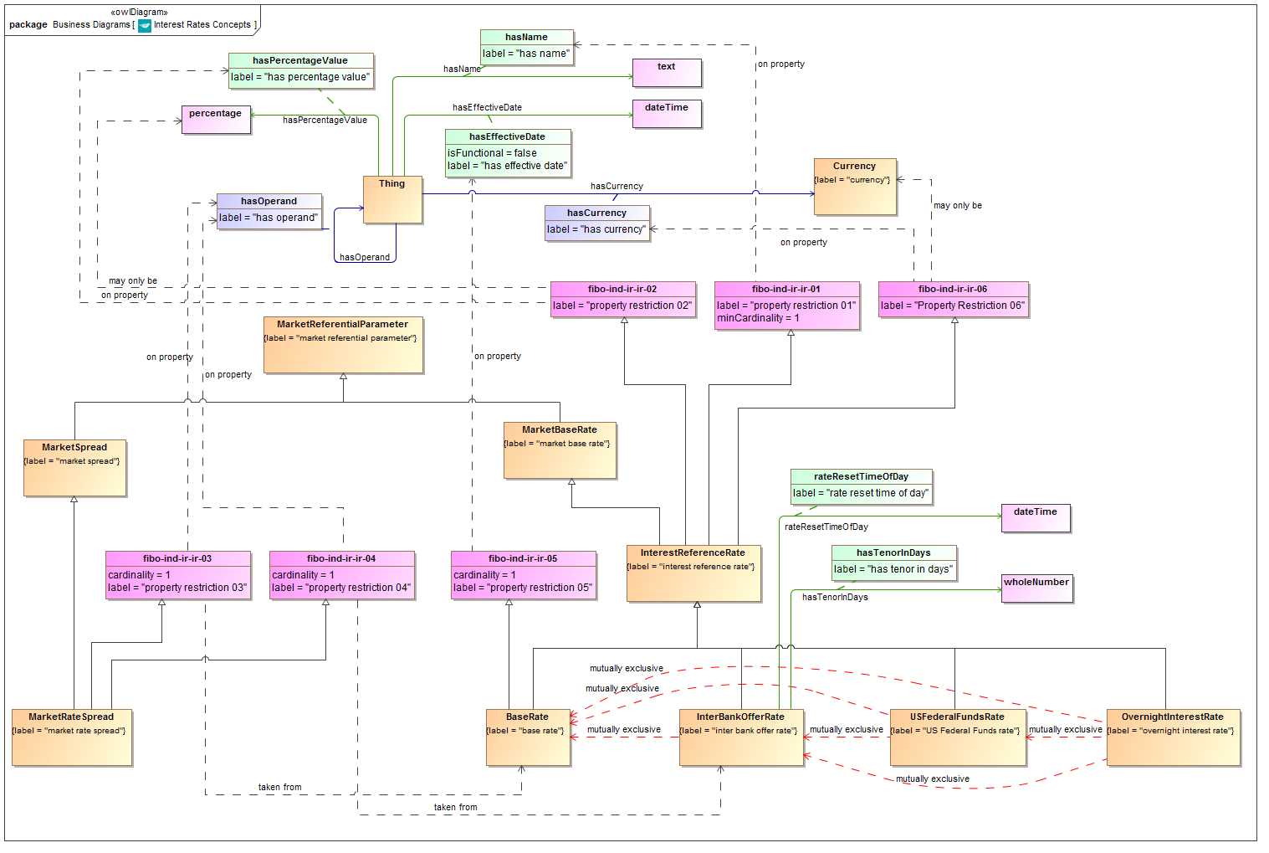

**Figure 9.3 Interest Rates Concepts**

Diagram showing all of the concepts in the Interest Rates ontology.

Table 9.9 Interest Rates Details

| **Concept Type** | **Name** | **Type Of Thing** | **Property** | **Definition** | **Parent** | **Mutually Exclusive With** | **Related Thing or Type** | **Inverse Of Property** | **Multiples** | **Editorial Note** | **Explanatory Note** | **Term Origin** | **Definition Source** |
| --- | --- | --- | --- | --- | --- | --- | --- | --- | --- | --- | --- | --- | --- |
| Class | BaseRate | base rate |  | The base rate set by a central bank for a given currency. | interest reference rate property restriction 05 | overnight interest rate inter bank offer rate US Federal Funds rate |  |  |  |  | This is set at intervals. |  |  |
| Class | InterBankOfferRate | inter bank offer rate |  | A interest rate at which banks lend to one another. | interest reference rate | US Federal Funds rate overnight interest rate base rate |  |  |  |  |  |  |  |
| Class | InterestReferenceRate | interest reference rate |  | a rate of interest paid by or agreed among some bank or set of banks | market base rate property restriction 01 property restriction 02 Property Restriction 06 |  |  |  |  |  |  |  |  |
| Class | MarketRateSpread | market rate spread |  | A rate formed from the difference between an interest rate and a lending rate, each for a given duration. | market spread property restriction 03 property restriction 04 |  |  |  |  |  | An example of this is a TED spread specifically for LIBOR and Fed funds Rate. |  |  |
| Class | OvernightInterestRate | overnight interest rate |  | The rate of interest that is offered for overnight deposits. | interest reference rate | base rate inter bank offer rate US Federal Funds rate |  |  |  |  | This forms the underlying in Overnight Interest Rate Swaps (IOS). |  |  |
| Class | USFederalFundsRate | US Federal Funds rate |  | The effective fed funds rate is a dollar-weighted average of interest rates payable on overnight Fed funds. It is compiled daily by the New York Federal Reserve Bank and is based on transactions arranged by major brokers. | interest reference rate | overnight interest rate inter bank offer rate base rate |  |  |  |  |  |  |  |
| Simple Property | hasTenorInDays | inter bank offer rate | has tenor in days | The length of time for which the IBOR is quoted, e.g. 3 months, 6 months and so on. |  |  | whole number |  |  | This is given as a whole number representing the number of days, because the concept of a duration is not yet modeled semantically, otherwise this term would refer to duration as its range instead. The name of this property reflects this compromise and would be changed to "Tenor" once a suitable range exists for this property. |  |  |  |
| Simple Property | rateResetTimeOfDay | inter bank offer rate | rate reset time of day | The time of day when the rate is reset e.g. 11:00 |  |  | xsd:dateTime |  |  |  |  |  |  |
| Property Restriction | fibo-ind-ir-ir-01 | property restriction 01 | has name | Set of things that have the property shown, in the multiples given, taken from the type of thing indicated. |  |  |  |  | at least 1 |  |  |  |  |
| Property Restriction | fibo-ind-ir-ir-02 | property restriction 02 | has percentage value | Set of things which, if they have the property shown, any participants in that relationship may only be taken from the type of thing indicated. |  |  | percentage |  | may only be |  |  |  |  |
| Property Restriction | fibo-ind-ir-ir-03 | property restriction 03 | has operand | Set of things that have the property shown, in the multiples given, taken from the type of thing indicated. |  |  | base rate |  | exactly 1 |  |  |  |  |
| Property Restriction | fibo-ind-ir-ir-04 | property restriction 04 | has operand | Set of things that have the property shown, in the multiples given, taken from the type of thing indicated. |  |  | interbank offer rate |  | exactly 1 |  |  |  |  |
| Property Restriction | fibo-ind-ir-ir-05 | property restriction 05 | has effective date | Set of things that have the property shown, in the multiples given, taken from the type of thing indicated. |  |  |  |  | exactly 1 |  |  |  |  |
| Property Restriction | fibo-ind-ir-ir-06 | Property Restriction 06 | has currency | Set of things which, if they have the property shown, any participants in that relationship may only be taken from the type of thing indicated. |  |  | currency |  | may only be |  |  |  |  |

### 9.4.2 Ontology: Interest Rate Publishers

This ontology provides concepts descriptive of the publishers of interest rates, such as banks and the bodies which publish inter-bank offer rates.

Table 9.10 Interest Rate Publishers Ontology Metadata

|  |  |
| --- | --- |
| **Metadata Term** | **Value** |
| **sm:filename** | InterestRatePublishers |
| **sm:fileAbbreviation** | fibo-ind-ir-pub |
| **OntologyIRI** | http://www.omg.org/spec/EDMC-FIBO/IND/InterestRates/InterestRatePublishers/ |
| **owl:versionIRI** | http://www.omg.org/spec/EDMC-FIBO/IND/20140201/InterestRates/InterestRatePublishers/ |
| **sm:dependsOn** | http://www.omg.org/techprocess/ab/SpecificationMetadata/  http://www.omg.org/spec/EDMC-FIBO/FND/Utilities/AnnotationVocabulary/ |

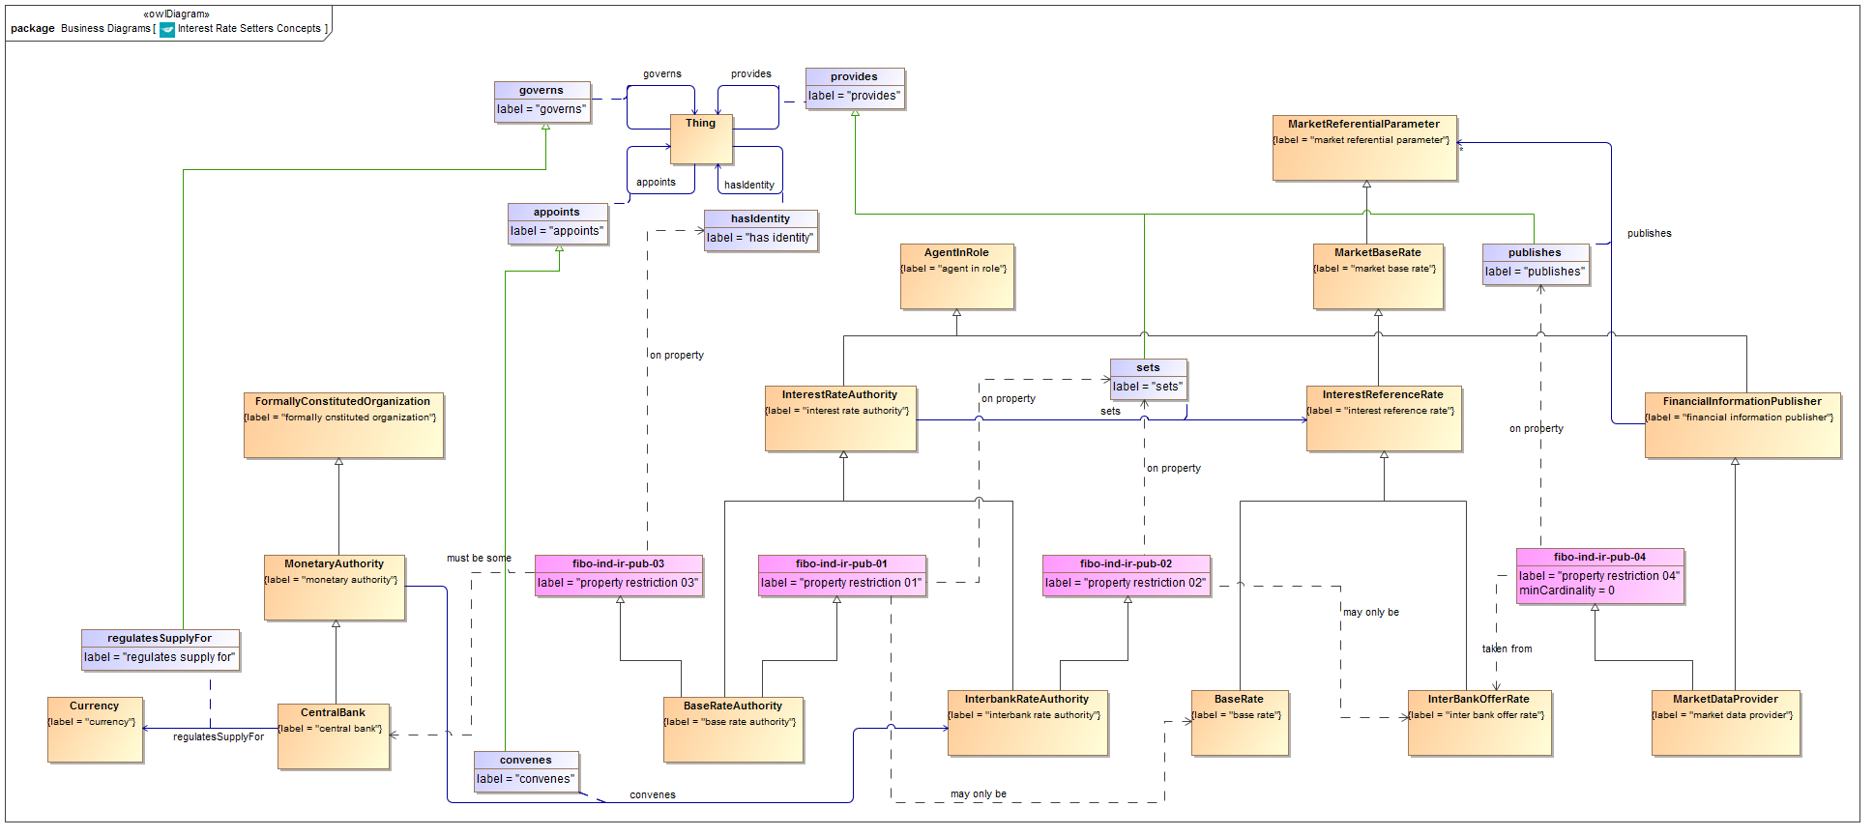

**Figure 9.4 Interest Rate Publishers Concepts**

Diagram showing all of the concepts in the Interest Rate Publishers ontology.

Table 9.11 Interest Rate Publishers Details

| **Concept Type** | **Name** | **Type Of Thing** | **Property** | **Definition** | **Parent** | **Mutually Exclusive With** | **Related Thing or Type** | **Inverse Of Property** | **Multiples** | **Editorial Note** | **Explanatory Note** | **Term Origin** | **Definition Source** |
| --- | --- | --- | --- | --- | --- | --- | --- | --- | --- | --- | --- | --- | --- |
| Class | BaseRateAuthority | base rate authority |  | The authority responsible for setting the base rate for a given currency. This would normally be a central bank. | interest rate authority property restriction 01 property restriction 03 |  |  |  |  |  |  |  |  |
| Class | CentralBank | central bank |  | A bank which regulates the monetary supply for a given economy and currency. | monetary authority |  |  |  |  |  |  |  |  |
| Class | InterbankRateAuthority | interbank rate authority |  | The authority responsible for setting the Interbank lending rate. | interest rate authority property restriction 02 |  |  |  |  | Note that since the time of cunducting the reviews that led to these definitions, the LIBOR scandal took place in Londonand many of the arrangements described here have changed. There are other variations in how different interbank offer rates are set, which may also vary from what is modeled here or may have changed. | This is announced by the relevant Central Bank at intervals following a meeting of the relevant policy group or committee. Thomson Reuters is the publisher for LIBOR, but this is set by the British Bankers Association (BBA). |  |  |
| Class | InterestRateAuthority | interest rate authority |  | The authority or entity which is responsible for the publication of some interest rate. | agent in role |  |  |  |  |  | Interest rates which are referred to as market base rates, for example as used in interest rate derivatives, are published by some body which is responsible for the rate as a kind of market data. In general, all market data is not only information, but information published by someone. |  |  |
| Class | MarketDataProvider | market data provider |  | An entity which provides data or information about the financial markets. This is usually either a publishing house or a specialized market data vendor. | financial information publisher property restriction 04 |  |  |  |  |  |  |  |  |
| Class | MonetaryAuthority | monetary authority |  | Proxy for MarketAuthority, to enable the addition of assertions in this ontology. |  |  |  |  |  | Added as a proxy to support the assertion "convenes" which has this as a domain and InterbankRateAuthority as its range |  |  |  |
| Relationship Property | regulatesSupplyFor | central bank | regulates supply for | The currency issued by the central bank and for which it is responsible for the money supply. | governs |  | currency |  |  |  |  |  |  |
| Relationship Property | sets | interest rate authority | sets | The interest rate authority (such as a central bank or monetary authority or a panel working behalf of such) determines and sets the interest reference rate which is in force at a given time. | provides |  | interest reference rate |  |  |  |  |  |  |
| Relationship Property | convenes | monetary authority | convenes | The body responsible for setting the interbank offer rate is convened by or on behalf of the central bank or some other monetary authority. | appoints |  | interbank rate authority |  |  |  | An Interbank Lending Rate is announced by the relevant Central Bank at intervals following a meeting of the relevant policy group or committee. |  |  |
| Property Restriction | fibo-ind-ir-pub-01 | property restriction 01 | sets | Set of things which, if they have the property shown, any participants in that relationship may only be taken from the type of thing indicated. |  |  | base rate |  | may only be |  |  |  |  |
| Property Restriction | fibo-ind-ir-pub-02 | property restriction 02 | sets | Set of things which, if they have the property shown, any participants in that relationship may only be taken from the type of thing indicated. |  |  | interbank offer rate |  | may only be |  |  |  |  |
| Property Restriction | fibo-ind-ir-pub-03 | property restriction 03 | has identity | Set of things with the property shown, where at least one participant in that relationship must be taken from the type of thing indicated. |  |  | central bank |  | must be some |  |  |  |  |
| Property Restriction | fibo-ind-ir-pub-04 | property restriction 04 | publishes | Set of things that have the property shown, in the multiples given, taken from the type of thing indicated. |  |  | interbank offer rate |  | at least 0 |  |  |  |  |

## 9.5 Module: Market Indicators

Table 9.12 Market Indicators Module Metadata

|  |  |
| --- | --- |
| **Metadata Term** | **Value** |
| **sm:moduleName** | MarketIndicators |
| **sm:moduleAbbreviation** | FIBO-IND-MEI |
| **sm:moduleVersion** | 1.0 |
| **sm:moduleAbstract** | This module includes ontologies defining concepts to do with published economic indicators. These give some indication of the state of some economy. Indicators of this type are usually published by governments or government agencies, or by international agencies or agencies of countries other than the ones reported on. Examples include Gross Domestic Product (GDP) and unemployment rates. |

### 9.5.1 Ontology: Market Indicators

This ontology provides the parameters which make up the various types of market economic indicators, along with basic facts about these such as the economies or countries they apply to.

Table 9.13 Market Indicators Ontology Metadata

| **Metadata Term** | **Value** |
| --- | --- |
| **sm:filename** | MarketIndicators |
| **sm:fileAbbreviation** | fibo-ind-mei-mei |
| **OntologyIRI** | http://www.omg.org/spec/EDMC-FIBO/IND/MarketIndicators/MarketIndicators/ |
| **owl:versionIRI** | http://www.omg.org/spec/EDMC-FIBO/IND/20140201/MarketIndicators/MarketIndicators/ |
| **sm:dependsOn** | http://www.omg.org/techprocess/ab/SpecificationMetadata/  http://www.omg.org/spec/EDMC-FIBO/FND/Utilities/AnnotationVocabulary/ |

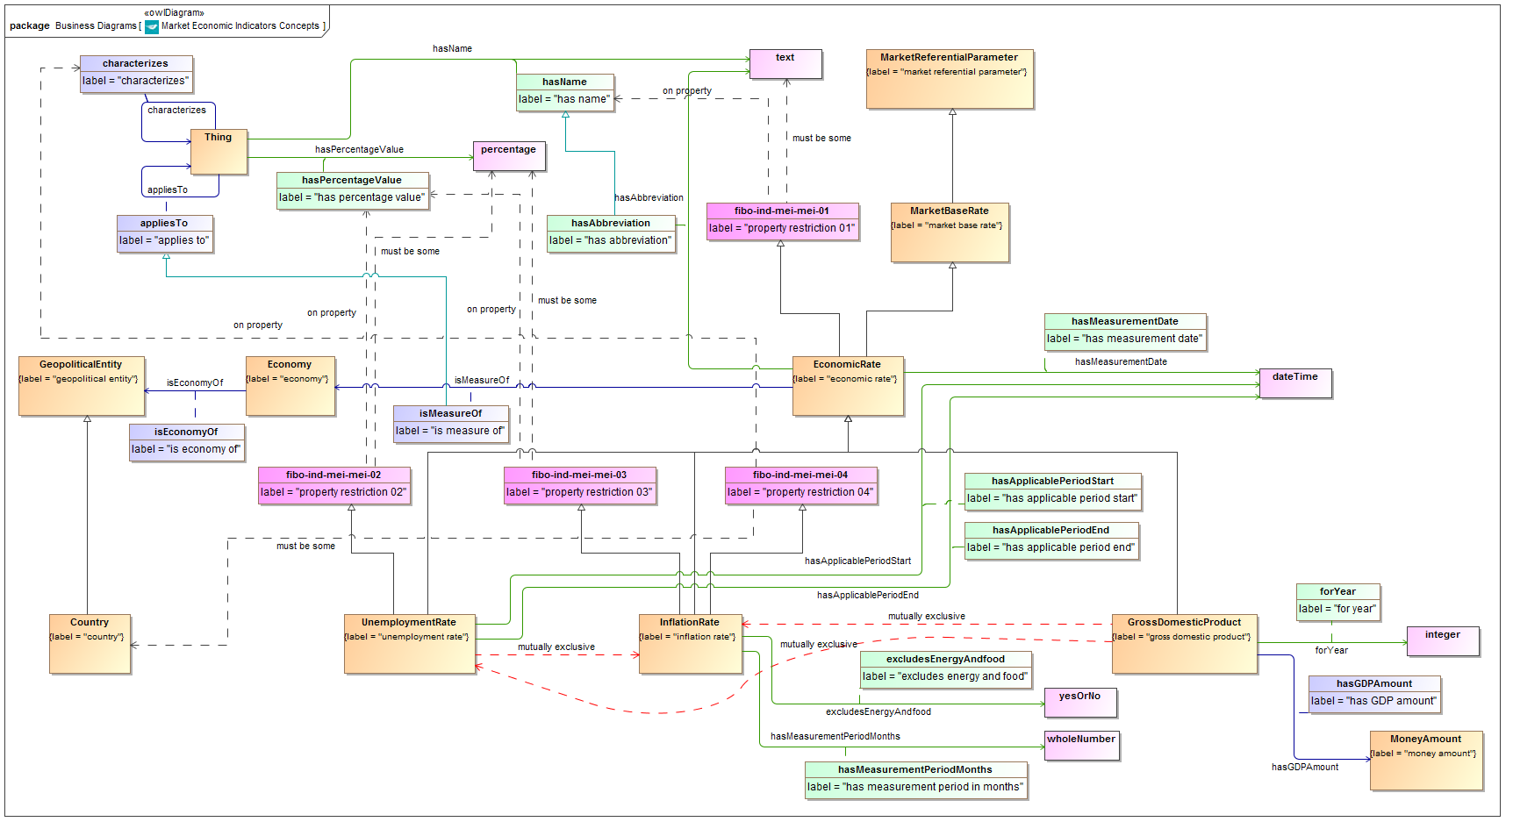

**Figure 9.5 Market Indicators Concepts**

Diagram showing all of the concepts in the Market Indicators ontology.

Table 9.14 Market Indicators Details

| **Concept Type** | **Name** | **Type Of Thing** | **Property** | **Definition** | **Parent** | **Mutually Exclusive With** | **Related Thing or Type** | **Inverse Of Property** | **Multiples** | **Editorial Note** | **Explanatory Note** | **Term Origin** | **Definition Source** |
| --- | --- | --- | --- | --- | --- | --- | --- | --- | --- | --- | --- | --- | --- |
| Class | EconomicRate | economic rate |  | A market based Index as published by some entity to provide a some measure of economic performance. | market base rate property restriction 01 |  |  |  |  |  |  |  |  |
| Class | Economy | economy |  | A geographically distinct web of economic relationships. |  |  |  |  |  |  |  |  |  |
| Class | GrossDomesticProduct | gross domestic product |  | The total output of the economy. | economic rate | unemployment rate inflation rate |  |  |  |  |  |  |  |
| Class | InflationRate | inflation rate |  | The annual percent change in consumer prices compared with the previous year's consumer prices, for a given country. | economic rate property restriction 03 property restriction 04 | unemployment rate gross domestic product |  |  |  |  |  |  |  |
| Class | UnemploymentRate | unemployment rate |  | A published rate of unemployment for a given economy. | economic rate property restriction 02 | gross domestic product inflation rate |  |  |  |  |  |  |  |
| Relationship Property | isMeasureOf | economic rate | is measure of | The economy of which the econmic rate applies. | applies to |  | economy |  |  |  |  |  |  |
| Simple Property | hasMeasurementDate | economic rate | has measurement date | The date at which the published figure applies. |  |  | xsd:dateTime |  |  |  |  |  |  |
| Simple Property | hasAbbreviation | economic rate | has abbreviation | The recognized abbreviation of the Index, e.g. RPI. | has name |  | text |  |  |  |  |  |  |
| Relationship Property | isEconomyOf | economy | is economy of | The geographical region, area etc. or the geopolitical construct (state, country) in which the economy is defined. |  |  | geopolitical entity |  |  |  |  |  |  |
| Relationship Property | hasGDPAmount | gross domestic product | has GDP amount | The actual value of the GDP for the applicable period, stated as a monetary amount. |  |  | money amount |  |  |  |  |  |  |
| Simple Property | forYear | gross domestic product | for year | The year for which the GDP figure applies. |  |  | xsd:integer |  |  | Review whether this needs additional qualifying terms, e.g. the applicable year end for that country.  The year is represented as a whole number (integer) because it is not possible to reference a datatype here which represents a year. |  |  |  |
| Simple Property | hasMeasurementPeriodMonths | inflation rate | has measurement period in months | The period of time up to the quoted date, to which the inflation rate applies. |  |  | whole number |  |  | At present, since the conceptof a date period has not been modeled semantically, this is given simplyas a whole number which is the number of months, since this kind of figure is generally quoted in months. | For example, for an inflation rate quoted for the 6 months to December 2009, this would be 6 months. |  |  |
| Simple Property | excludesEnergyAndfood | inflation rate | excludes energy and food | Whether the index excludes energy and food prices. |  |  | yes or no |  |  |  |  |  |  |
| Simple Property | hasApplicablePeriodStart | unemployment rate | has applicable period start | Start of the period to which the stated value of the unemployment rate applies. |  |  | xsd:dateTime |  |  | The class "Unemployment Rate" or a class representing its value, should be framed in terms of a date period. Since the concept of a date period has not yet been modeled semantically, the property which would have been "Applicable Period" is instead modeled as two properties representing the start and end date of that period (this would be a period denominated in days). |  |  |  |
| Simple Property | hasApplicablePeriodEnd | unemployment rate | has applicable period end | End of the period to which the stated value of the unemployment rate applies. |  |  | xsd:dateTime |  |  | The class "Unemployment Rate" or a class representing its value, should be framed in terms of a date period. Since the concept of a date period has not yet been modeled semantically, the property which would have been "Applicable Period" is instead modeled as two properties representing the start and end date of that period (this would be a period denominated in days). |  |  |  |
| Property Restriction | fibo-ind-mei-mei-01 | property restriction 01 | has name | Set of things with the property shown, where at least one participant in that relationship must be taken from the type of thing indicated. |  |  | text |  | must be some |  |  |  |  |
| Property Restriction | fibo-ind-mei-mei-02 | property restriction 02 | has percentage value | Set of things with the property shown, where at least one participant in that relationship must be taken from the type of thing indicated. |  |  | percentage |  | must be some |  |  |  |  |
| Property Restriction | fibo-ind-mei-mei-03 | property restriction 03 | has percentage value | Set of things with the property shown, where at least one participant in that relationship must be taken from the type of thing indicated. |  |  | percentage |  | must be some |  |  |  |  |
| Property Restriction | fibo-ind-mei-mei-04 | property restriction 04 | characterizes | Set of things with the property shown, where at least one participant in that relationship must be taken from the type of thing indicated. |  |  | country |  | must be some |  |  |  |  |

### 9.5.2 Ontology: Indicator Publishers

This ontology provides concepts descriptive of the publishers of market indicators, such as gross domestic product, employment statistics, inflation rates and so on. These may include government or quasi-government bodies, international agencies, third parties and data providers.

Table 9.15 Indicator Publishers Ontology Metadata

|  |  |
| --- | --- |
| **Metadata Term** | **Value** |
| **sm:filename** | IndicatorPublishers |
| **sm:fileAbbreviation** | fibo-ind-mei-pub |
| **OntologyIRI** | http://www.omg.org/spec/EDMC-FIBO/IND/MarketIndicators/IndicatorPublishers/ |
| **owl:versionIRI** | http://www.omg.org/spec/EDMC-FIBO/IND/20140201/MarketIndicators/IndicatorPublishers/ |
| **sm:dependsOn** | http://www.omg.org/techprocess/ab/SpecificationMetadata/  http://www.omg.org/spec/EDMC-FIBO/FND/Utilities/AnnotationVocabulary/ |

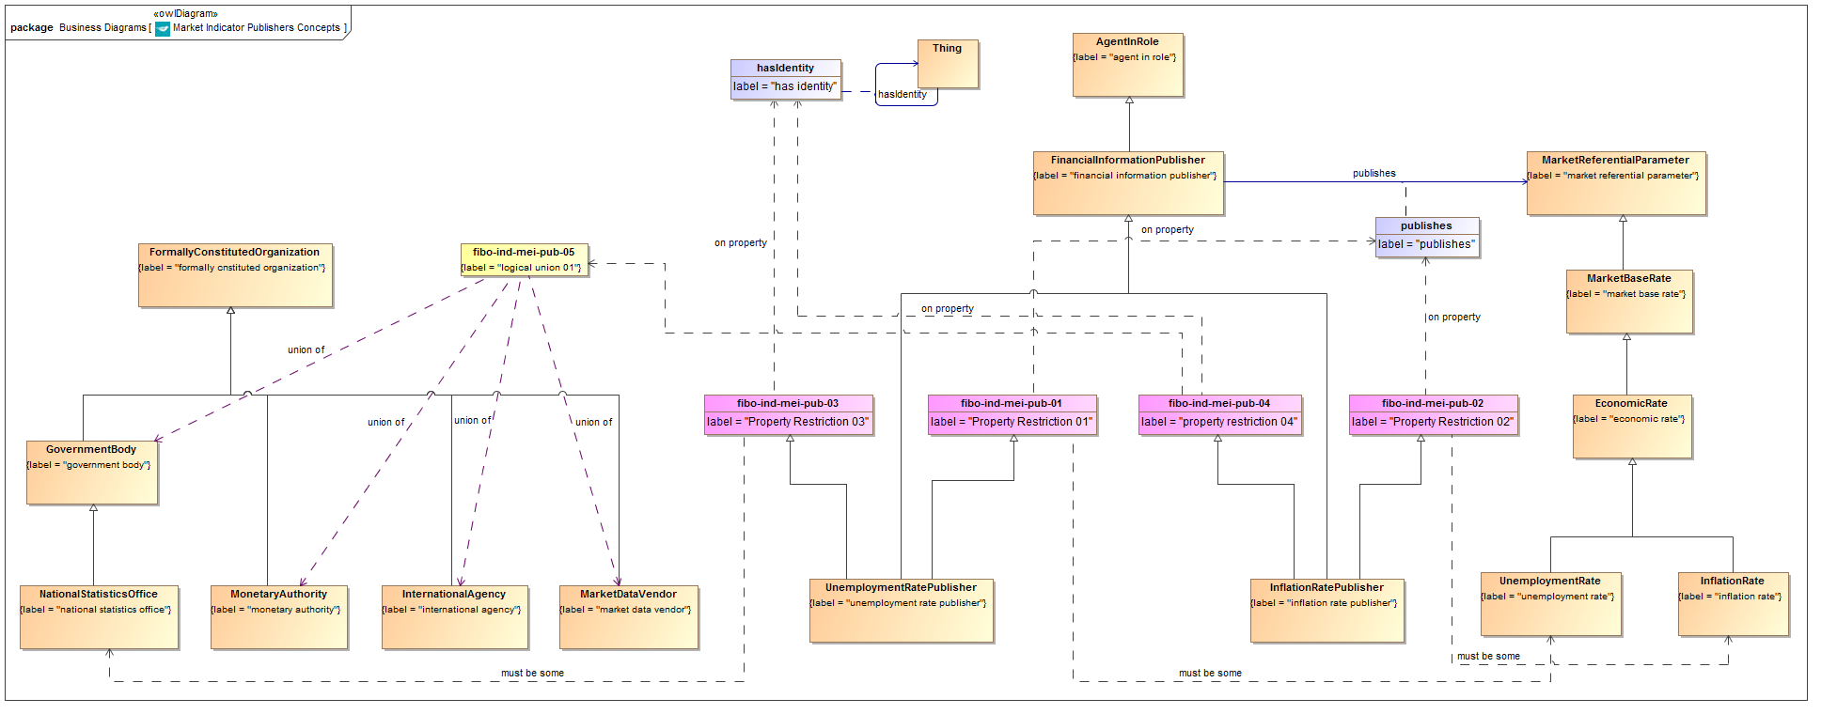

**Figure 9.6 Indicator Publishers Concepts**

Diagram showing all of the concepts in the Indicators Publishers ontology.

Table 9.16 Indicator Publishers Details

| **Concept Type** | **Name** | **Type Of Thing** | **Property** | **Definition** | **Parent** | **Mutually Exclusive With** | **Related Thing or Type** | **Inverse Of Property** | **Multiples** | **Editorial Note** | **Explanatory Note** | **Term Origin** | **Definition Source** |
| --- | --- | --- | --- | --- | --- | --- | --- | --- | --- | --- | --- | --- | --- |
| Class | GovernmentBody | government body |  | An individual organization which forms part of the mechanisms of government, and through which a government (which is a relative entity) discharges its functions in governing. | formally cnstituted organization |  |  |  |  | Definition to be reviewed; terms and hierarchies to be added for completeness. |  |  |  |
| Class | InflationRatePublisher | inflation rate publisher |  | The entity which publishes some inflation rate for a given economy | financial information publisher Property Restriction 02 property restriction 04 |  |  |  |  |  | Inflation rates maybe published by one of a variety of kinds of entity for the economy and rate in question. |  |  |
| Class | InternationalAgency | international agency |  | A body set up internationally which operates internationally. | formally cnstituted organization |  |  |  |  |  |  |  |  |
| Class | MarketDataVendor | market data vendor |  | A business entity which specializes in the sourcing and distribution of financial market data. | formally cnstituted organization |  |  |  |  |  |  |  |  |
| Class | MonetaryAuthority | monetary authority |  | Some formal organization tasked with some or all of the tasks relating to the monetary policy, regulation and supply for some currency or in some country or group of countries. | formally cnstituted organization |  |  |  |  | This item was added subsequent to the original SME reviews of this material. This item is referenced in InterestRatePublushers as the parent of CentralBank Meanwhile in this IndicatorsPublishers ontology, the union which previously included CentralBank now includes this concept instead. Rationale: A detailed description of the LIBOR arrangements was given at the time of the original SME reviews, and assumed to apply to other interbank offer rates. Subsequently the LIBOR scandal of 2012 led to considerable changes to these arrangements. In particular the panel responsible for setting LIBOR now answers to the Financial Conduct Authority (FCA). Similarly Euribor is set by a committee which is not convened by the European Central Bank. Therefore the more general concept of a Monetary Authority was introduced, of which central bank and (not shown) regulatory authorities would be examples. Many of the items which previously referenced CentralBank in both ontologies now reference this new concept. |  |  |  |
| Class | NationalStatisticsOffice | national statistics office |  | The government body responsible for publishing statistics for a country or economic area. | government body |  |  |  |  |  | Usually would be the publisher for both inflation rates and unemployment rates. For example in the US the same office provides unemployment rates and inflation rates. |  |  |
| Class | UnemploymentRatePublisher | unemployment rate publisher |  | The body which initially determines and publishes the unemployment rate for a given economic area. | financial information publisher Property Restriction 01 Property Restriction 03 |  |  |  |  |  |  |  |  |
| Restriction Property | fibo-ind-mei-pub-01 | Property Restriction 01 | publishes | Set of things with the property shown, where at least one participant in that relationship must be taken from the type of thing indicated. |  |  | unemployment rate |  | must be some |  |  |  |  |
| Restriction Property | fibo-ind-mei-pub-02 | Property Restriction 02 | publishes | Set of things with the property shown, where at least one participant in that relationship must be taken from the type of thing indicated. |  |  | inflation rate |  | must be some |  |  |  |  |
| Restriction Property | fibo-ind-mei-pub-03 | Property Restriction 03 | has identity | Set of things with the property shown, where at least one participant in that relationship must be taken from the type of thing indicated. |  |  | national statistics office |  | must be some |  |  |  |  |
| Restriction Property | fibo-ind-mei-pub-04 | property restriction 04 | has identity | Set of things with the property shown, where at least one participant in that relationship must be taken from the type of thing indicated. |  |  | logical union 01 |  | must be some |  |  |  |  |
| logical union | fibo-ind-mei-pub-05 | logical union 01 |  | Logical union of the items shown. |  |  | national statistics office, monetary authority, international agency, market data vendor |  |  |  |  |  |  |

# Annex A: Deliverables Included with this RFC

(normative)

The FIBO ontologies are delivered as (1) RDF/XML serialized OWL (normative and definitive), (2) UML XMI, serialized from UML with the ODM profiles for RDF and OWL applied (normative), (3) ODM XMI, serialized based on the ODM MOF metamodels for RDF and OWL (normative), and (4) Visual Ontology Modeler (VOM) model files, based on the VOM plug-in to MagicDraw (informative). If there are differences between the OWL files, ODM XMI, and UML XMI, the OWL files take precedence, followed by the UML XMI, and finally the ODM XMI.

Regardless of their form, each of the ontologies included in Indices and Indicators makes normative reference to the DCMI Dublin Core Metadata Terms[1], W3C Simple Knowledge Organization System (SKOS) Recommendation[2], and the OMG Architecture Board’s Specification Metadata Recommendation[3], which are not part of this specification.

The individual RDF/XML files are organized by module (directory), and within a given module, alphabetically by name, as shown in the URI structure for each individual OWL file. These files are UTF-8 conformant XML Schema files that are also OWL 2 compliant, and may be examined using any text editor, XML editor, or RDF or OWL editor. They have been verified for syntactic correctness via the W3C RDF Validator and University of Manchester OWL 2 Validator. They have also been checked for logical consistency using the Pellet OWL 2 reasoner from Clark & Parsia as well as the HermiT OWL 2 reasoner from Oxford University. It is anticipated that the OWL ontologies will be dereference-able, together with technical documentation (HTML) from the OMG site once the specification is adopted.

# Annex B: Effect of Changes in FIBO Foundations

Informative

The result of the changes to [FIBO Foundations] specified in detail in sub-clause 3.3 of this specification will be the generation of new business facing diagrams and tabular reports in Chapter 10 of that document. These are replicated here so as to illustrate the heading and formatting, but would be generated directly from the model tool following implementation of the changes described in sub-clause 3.3.

In the sub-clauses describing each ontology there will be a diagram and a detailed table of terms. These are as follows:

## 10.1 Module: Utilities

### 10.1.2 Ontology: Business Facing Types

After Figure 10.2:

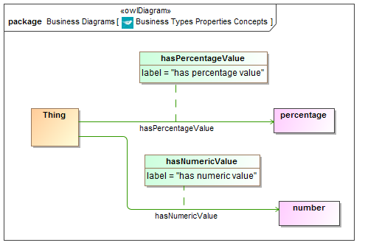

**Figure 10.3 Business Facing Types Properties Concepts**

After Table 10.6:

Table 10.7 Business Facing Types Details

| **Concept Type** | **Name** | **Type Of Thing** | **Property** | **Definition** | **Parent** | **Mutually Exclusive With** | **Related Thing or Type** | **Inverse Of Property** | **Multiples** | **Editorial Note** | **Explanatory Note** | **Term Origin** | **Definition Source** |
| --- | --- | --- | --- | --- | --- | --- | --- | --- | --- | --- | --- | --- | --- |
| Simple Property | hasPercentageValue |  | has percentage value | The value taken by some thing (typically the value taken by some parameter) expressed in percentage terms |  |  | percentage |  |  |  |  |  |  |
| Simple Property | hasNumericValue |  | has numeric value | The value taken by some thing (typically the value taken by some parameter) expressed as a number |  |  | number |  |  |  |  |  |  |

### 10.1.3 Ontology: Math

**Table 10.8 Math Ontology Metadata**

|  |  |
| --- | --- |
| **Metadata Term** | **Value** |
| **sm:filename** | Math |
| **sm:fileAbbreviation** | fibo-fnd-utl-math |
| **OntologyIRI** | http://www.omg.org/spec/EDMC-FIBO/FND/Utilities/Math/ |
| **owl:versionIRI** | http://www.omg.org/spec/EDMC-FIBO/FND/20140201/Utilities/Math/ |
| sm:dependsOn | <http://www.omg.org/spec/EDMC-FIBO/FND/Utilities/AnnotationVocabulary/>  <http://www.omg.org/spec/EDMC-FIBO/FND/Utilities/BusinessFacingTypes/> |

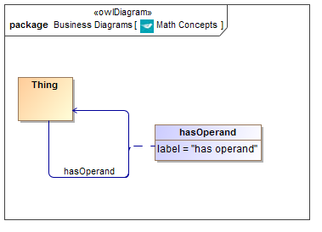

**Figure 10.4 Math Concepts**

New Table 10.9:

**Table 10.9 Math Properties Details**

| **Concept Type** | **Name** | **Type Of Thing** | **Property** | **Definition** | **Parent** | **Mutually Exclusive With** | **Related Thing or Type** | **Inverse Of Property** | **Multiples** | **Editorial Note** | **Explanatory Note** | **Term Origin** | **Definition Source** |
| --- | --- | --- | --- | --- | --- | --- | --- | --- | --- | --- | --- | --- | --- |
| Relationship Property | hasOperand |  | has operand | the operand of some mathematical parameter or thing |  |  |  |  |  |  |  |  |  |

## 10.2 Module: Relations

### 10.2.1 Ontology: Relations

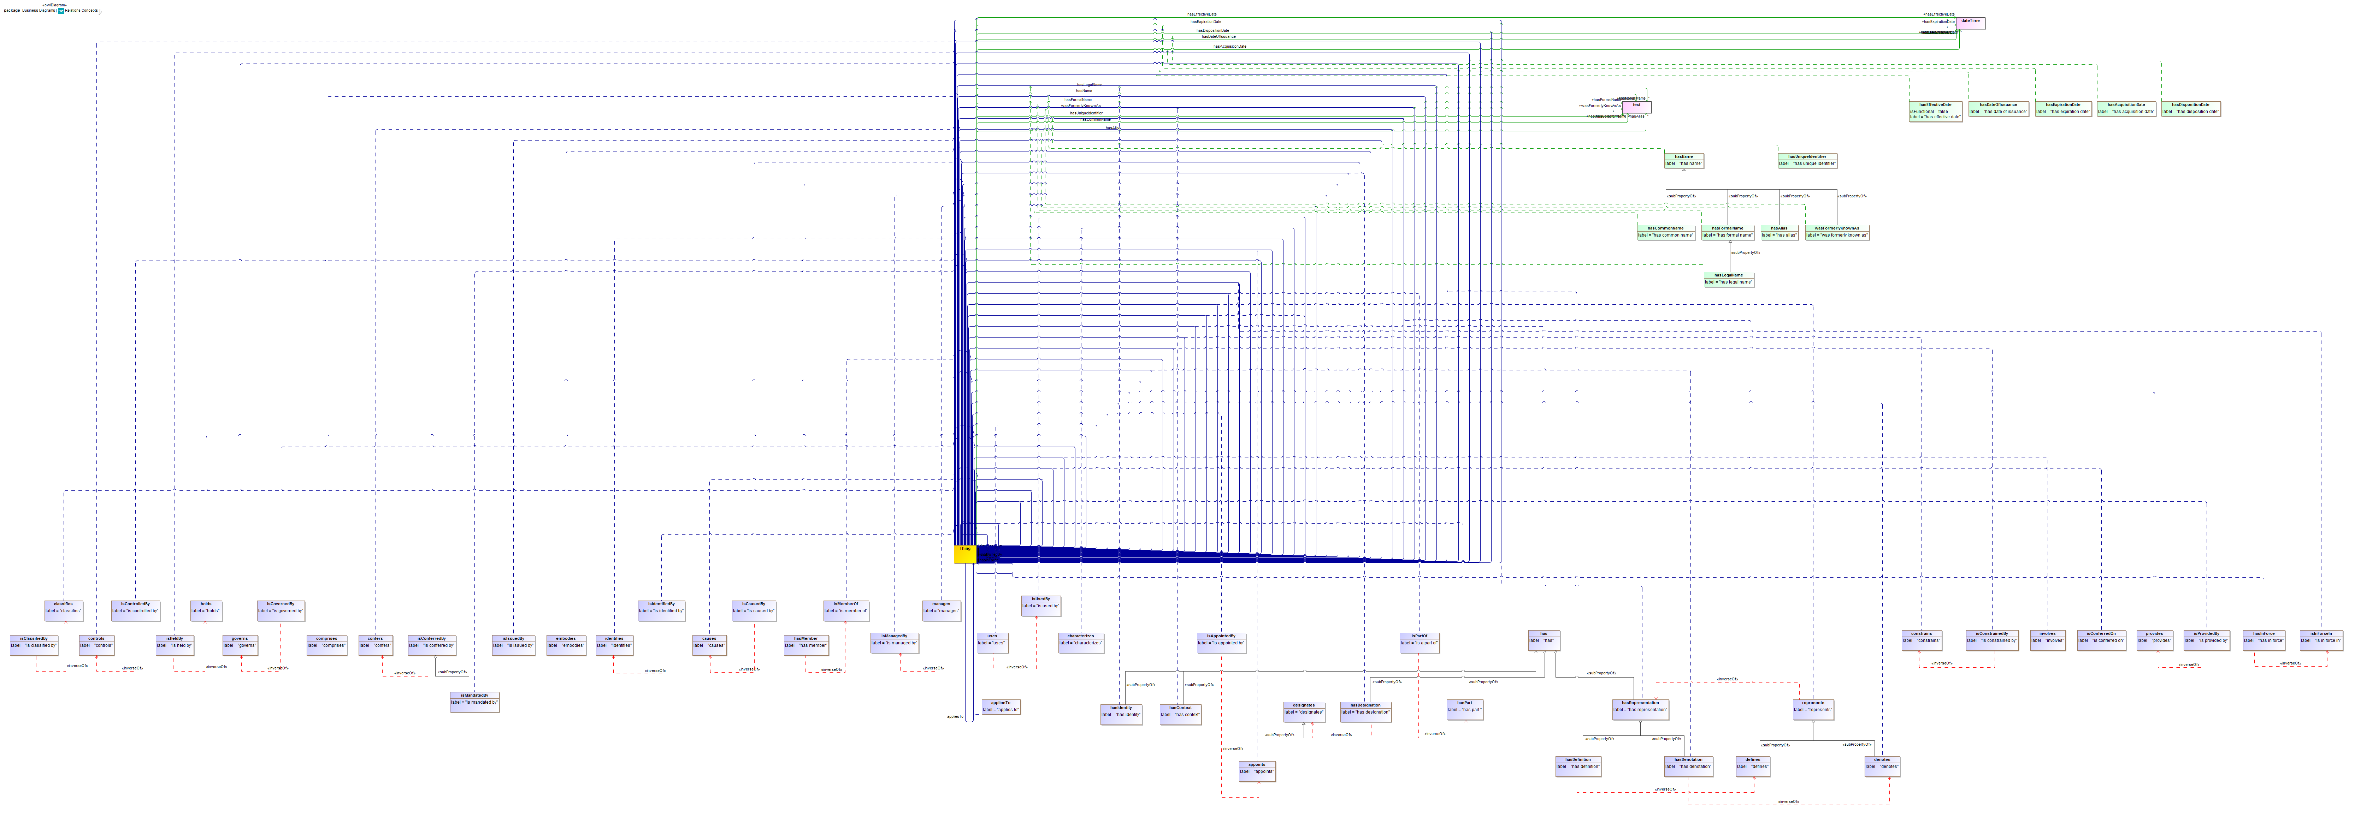

**Figure 10.5 Relations Concepts**

Additional line entry in the existing Table 10.9 (which would now be Table 10.10) for the new property:

Table 10.10 Relations Details

| **Concept Type** | **Name** | **Type Of Thing** | **Property** | **Definition** | **Parent** | **Mutually Exclusive With** | **Related Thing or Type** | **Inverse Of Property** | **Multiples** | **Editorial Note** | **Explanatory Note** | **Term Origin** | **Definition Source** |
| --- | --- | --- | --- | --- | --- | --- | --- | --- | --- | --- | --- | --- | --- |
| Relationship Property | appliesTo |  | applies to | That to which the thing (typically a mathematical parameter) is applicable, i.e. the thing in respect of which this thing is a parameter or measure or information of some sort |  |  |  |  |  |  |  |  |  |

1. http://www.dublincore.org/documents/dcmi-terms/
2. http://www.w3.org/TR/2009/REC-skos-reference-20090818/
3. http://www.omg.org/techprocess/ab/SpecificationMetadata/